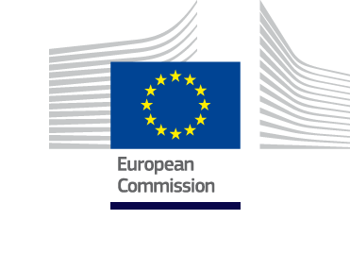

Annex 2

Instrument for Pre-accession Assistance

2014-2020

IPA CBC Programme
The former Yugoslav Republic of Macedonia - Republic of Albania
Adopted on 11/12/2014

Table of Contents

Instrument for Pre-accession Assistance 1
2014-2020 1
Acronyms 3
Programme synopsis 5
Section 1: Summary of Programme 6
1.1 Summary of the Programme 6
1.2 Preparation of the programme and involvement of the partners 7
Section 2: Programme Area 9
2.1 Situation Analysis – Synopsis 11
2.2 Main findings 13
Section 3: Programme Strategy 14
3.1 Rationale - Justification of the selected intervention strategy 15
3.2 Description of Programme Priorities 17
3.3 Horizontal and cross-cutting issues 35
Section 4: Financial Plan 37
Section 5: Implementing Provisions 38
LIST OF ANNEXES 40
ANNEX 1: Situation and SWOT Analyses 40
Situation Analysis of the Programme Area 40
SWOT Analysis 55

Acronyms

CBC | Cross-Border Co-operation
CfP | Call for Proposals
CSO | Community Support Organisation
DG | Directorate General
ERE | Electricity National Regulatory Authority (Republic of Albania)
EC | European Commission
EU | European Union
GBER | General Block Exemptions Regulation (EU)
GDP | Gross Domestic Product
GfA | Guidelines for Applicants
GVA | Gross Value Added
HR | Human Resources
ICT | Information and Communication Technology
INSTAT | Statistical Institute of the Republic of Republic of Albania
IPA | Instrument for Pre-accession Assistance
JTF | Joint Task Force
JTS | Joint Technical Secretariat
KPI | Key Performance Indicators
LFS | Labour Force Survey
LP | Lead Partner (Lead Partner Principle)
LSMS | Living Standards Measurement Study (World Bank)
MIS | Management Information System
MoU | Memorandum of Understanding
NACE | Statistical Classification of Economic Activities in the European Community
NATO | North Atlantic Treaty Organisation
NGO | Non-government Organisation
NIPAC | National IPA Co-ordinator
NSDI | National Strategy for Development and Integration (Republic of Albania)
NUTS | Nomenclature of Territorial Units for Statistics
OS | Operating Structure
PRAG | Practical Guidelines to Contract Procedures for EC external actions
RDI | Research, development and innovation
SBA | Small Business Act (EU)
SME | Small and medium enterprise, including micro firms
OMC | Open Method of Co-ordination for social protection and social inclusion (EU)
SWOT | Strengths, weaknesses, opportunities and threats analysis
TP | Thematic Priority

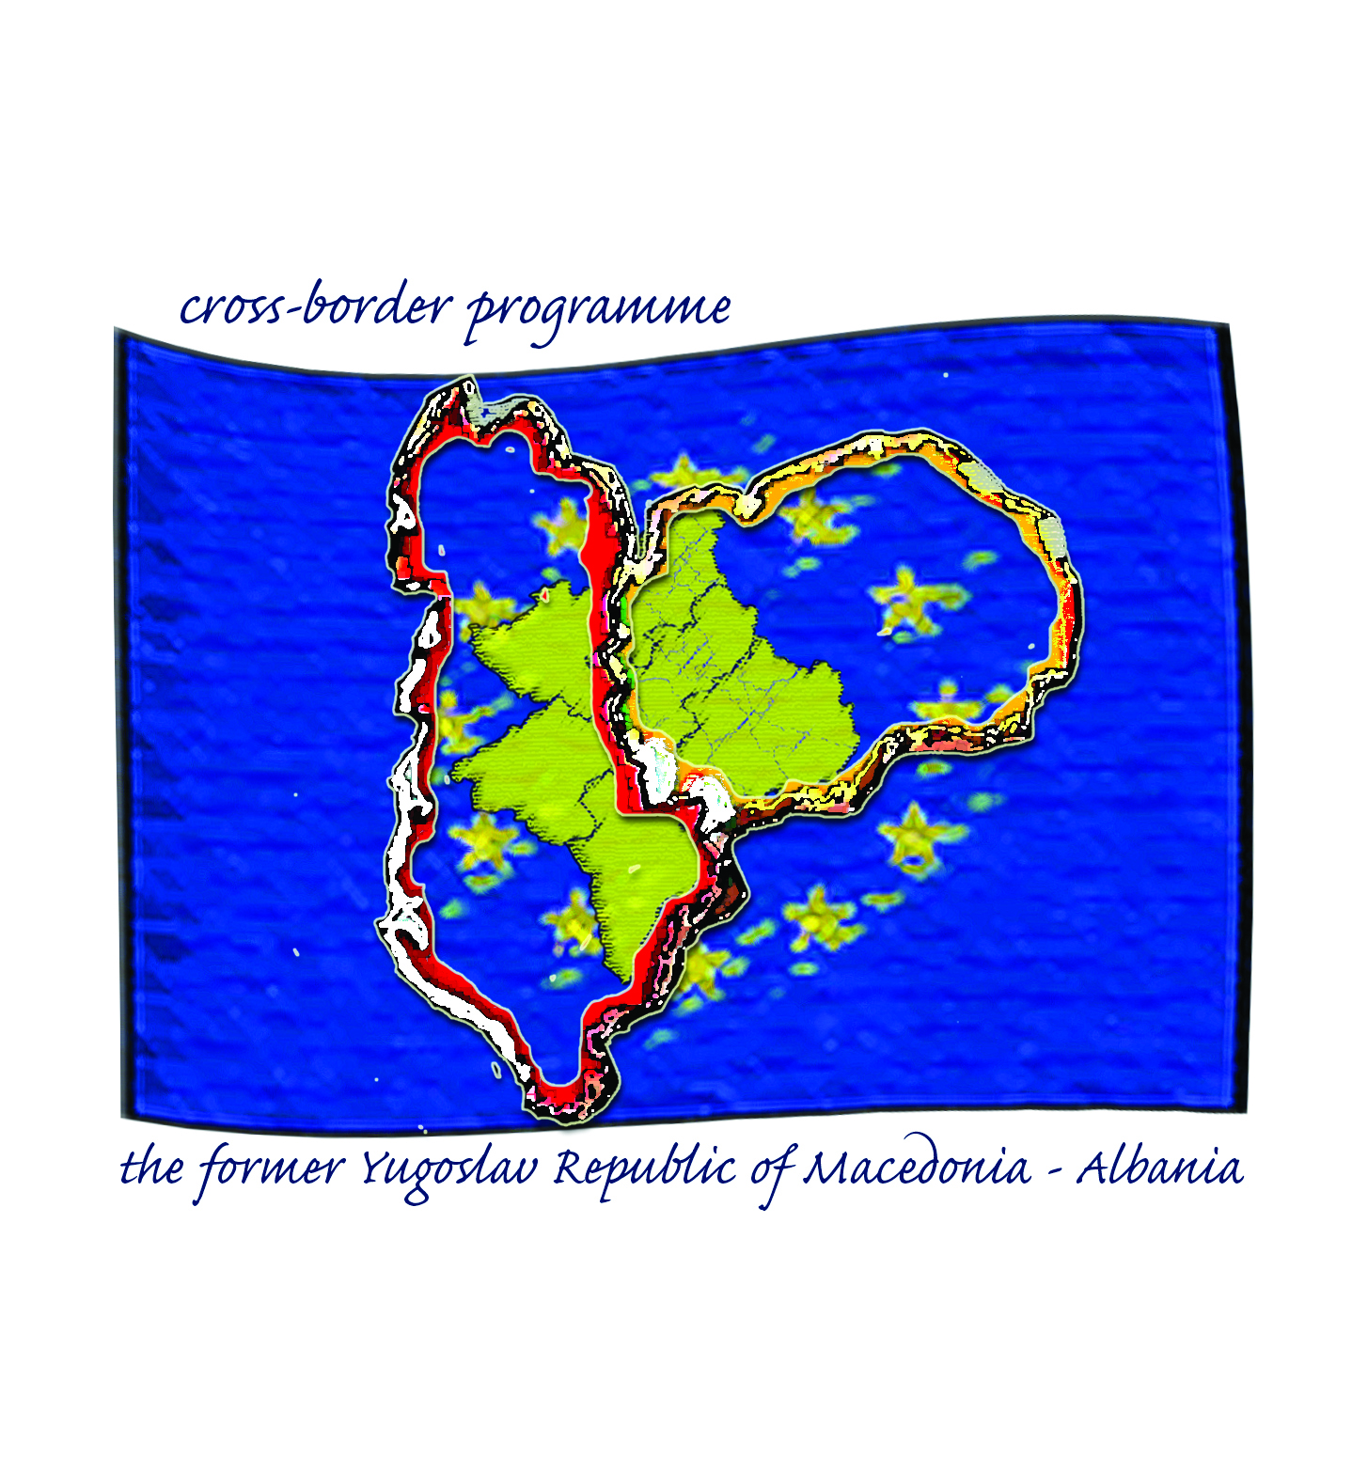

Programme synopsis

Programme title | CBC Programme: the former Yugoslav Republic of Macedonia and Republic of Albania
Programme area | the former Yugoslav Republic of Macedonia: Pelagonia, Polog, Southwest  Republic of Albania: Dibra, Elbasan, Korca
Programme overall objective | Stimulate more balanced, inclusive and sustainable socio-economic development of the Border Area
Programme thematic priorities | - Encouraging tourism, culture and natural heritage (TP4)  - Enhancing competitiveness, business, trade and investment (TP7)  - Protecting environment, promoting climate change adaptation and mitigation, risk prevention and management (TP2)  - Technical Assistance
Programme specific objectives | TP 1: Encouraging tourism, culture and natural heritage  SO 1: The potential of tourism is developed by promoting cultural heritage and values  TP 2: Enhancing competitiveness, business, trade and investment  SO 2: The SME productive capacity and access to markets are strengthened  TP 3: Protecting environment, promoting climate change adaptation and mitigation, risk prevention and management  SO 3: The awareness of a greener economy, cleaner environment and climate change is enhanced  Technical Assistance  Effective, efficient, transparent and timely implementation of the programme and awareness raising
Financial allocation 2014-2020 | EUR 11 900 000.00
Implementation method | Direct management
Contracting Authority | The Delegation of the European Union to the former Yugoslav Republic of Macedonia
Relevant authorities in the participating IPA II Beneficiaries | Ministry of Local Self-Government (the former Yugoslav Republic of Macedonia)  Ministry of European Integration (Republic of Albania)
JTS/Antenna | JTS in Struga, the former Yugoslav Republic of Macedonia  Antenna in Elbasan, Republic of Albania

Section 1: Summary of Programme

The programme for cross-border cooperation between the former Yugoslav Republic of Macedonia and Republic of Albania will be implemented under the framework of the Instrument for Pre-accession Assistance ( IPA II ). IPA II supports cross-border cooperation with a view to promoting good neighbourly relations, fostering union integration and promoting socio-economic development. The legal provisions for its implementation are stipulated in the following pieces of legislation:

• Regulation (EU) No 231/2014 of the European Parliament and of the Council of 11 March 2014 establishing an Instrument for Pre-accession Assistance (IPA II)
• Regulation (EU) No 236/2014 of the European Parliament and of the Council of 11 March 2014 laying down common rules and procedures for the implementation of the Union's instruments for financing external action
• Commission Implementing Regulation EU no 447/2014 of 2 May 2014 on the specific rules for implementing the IPA II regulation

1.1 Summary of the Programme

This Cross Border Co-operation Programme covers the period 2014-2020 and relates to the New Financial Perspective of the European Community. It has been designed on the basis of a detailed analysis of the situation in the programme area.

The former Yugoslav Republic of Macedonia-Republic of Albania border area features one of the most impoverished areas and one of the least favourable socio-economic development opportunities and conditions in the entire European continent due to rural, mountainous and remote character of the CBC Area. In addition, the present development situation of the Programme Area derives from a set of historically, demographically, politically, geographically and economically driven factors, which cannot be overcome in a short period of time.

The proposed intervention and activities stem from ‘problem tree’ combined with strategic balance sheet analysis and limited resource of the Programme. It aims to address the most important problem nodes and strategic opportunity identified through socio-economic and SWOT analysis, namely: i) low levels of economic activity along with mismatch of supply and demand in the labour market, ii) underdeveloped and obsolete environment infrastructure and iii) potential in tourism development and cultural exchange.

Realistically the Programme Area cannot expect to grow fast though it looks forward to a more balanced, inclusive and sustainable socio-economic development through testing new instruments and solution, learning from other regions and mobilisation and exploitation of endogenous potential. This could lead to higher standards of living, self-confidence and social security.

The Programme concentrates on three IPA II Regulation thematic priorities deriving from needs-opportunity analysis. These are, namely:

- Encouraging tourism and cultural and natural heritage (opportunity-driven);
- Enhancing competitiveness, business, trade and investment (needs and opportunity-driven);
- Protecting the environment, promoting climate change adaptation and mitigation, risk prevention and management (needs driven);

The CBC Programme includes also a Technical Assistance Priority.

1.2 Preparation of the programme and involvement of the partners

The process of programming of this IPA II CBC Programme for the former Yugoslav Republic of Macedonia-Republic of Albania commenced in July 2013. The entire programming course was based on common experience of the process that had taken place for the period 2007-2013.

The development of this Programme Document was steered by the Joint Task Force comprising of representatives of the two Operating Structures, delegates of NIPAC office in the two countries, representatives of the Programme Area NUTS-3 regions and some self-government units. The work of the JTF was facilitated and supported through CBIB+ Technical Assistance Project, funded by the EU that brought international best practice into the process.

Working sessions of the OSs and JTF were held throughout the whole programming phase in order to ensure effective communication leading to the identification of the Thematic Priorities to be addressed for the development Strategy of the Programme Area and setting up the appropriate implementing and monitoring structures. In addition to that consultations between the both OS’s took place within the framework of learning and networking facility under the auspicious of the CBIB+ Project:

Date/Location | Milestone
18/07/2013, Struga | Operating Structures meeting: identification of key challenges and issues; initial short-listing of Thematic Priorities and agreement on SWOT analysis
23/09/2013, Skopje | Kick-off meeting with the Ministry of Local Self Government, the Delegation of the European Union, the programming team and the national contact point in the former Yugoslav Republic of Macedonia
27/09/2013, Tirana | Strategy development and formulation training: 14 participants (OSs, JTF, JTS, CBIB+): explanation of IPA II CBC programming process, discussion of lessons learned from current programme(s), planning step by step (situation analysis, main findings (SWOT, needs), making strategic choices – selecting priorities, defining priorities, indicators and targets), checking of the intervention logic, horizontal and cross-cutting issues.
30/09/2013, Skopje | Strategy development and formulation training: 21 participants (OSs, JTF, JTS, CBIB+): explanation of IPA II CBC programming process, discussion of lessons learned from current programme(s), planning step by step (situation analysis, main findings (SWOT, needs), making strategic choices – selecting priorities, defining priorities, indicators and targets), checking of the intervention logic, horizontal and cross-cutting issues.
04/10/2013, Skopje | Joint Task Force meeting: feedback from initial SWOT analysis, meeting with Technical Assistance team, discussion on Thematic Priorities and intervention logic, steps to complete Programme document (14 participants)
24/10/2013, Struga | Joint Task Force meeting: inclusive situation and SWOT analysis, confirmation of Thematic Priorities and initial selection of Activities and operations; discussion on indicators; financial allocations
07/11/2013, Tirana | Joint Task Force meeting: discussion on Programme Intervention Strategy and Activities
21-22/11/2013, Belgrade | Regional CBC Consultative Forum
06/12/2013, Elbasan | Public consultation: the Programme Document was presented, as well as process of its development, choice of thematic priorities and upcoming steps. The choice of thematic priorities was confirmed by the stakeholders (14 participants).
11/12/2013, Tirana | Joint Monitoring Committee meeting: specific topic of the Agenda was presentation of the Programming Process 2014-2020 between the former Yugoslav Republic of Macedonia-Republic of Albania to the JMC representatives from line ministries of both countries, local government representatives, EUD’s and OS’s (36 representatives).
12/12/2013, Tirana | Technical meeting with OS’s, DG ENLARG, EUD and CBIB+: discussion on the Programme Strategy and other CBC programmes under development took place.
12/12/2013, Pogradec | Preliminary public consultation workshop: the programme document was presented to local stakeholders, as well as process of its development, choice of thematic priorities and upcoming steps. The choice of thematic priorities was confirmed by the stakeholders (11 participants).
13/12/2013, Korca | Preliminary public consultation workshop: the programme document was presented to local stakeholders, as well as process of its development, choice of thematic priorities and upcoming steps. The choice of thematic priorities was confirmed by the stakeholders (13 participants).
16/12/2013, Diber | Preliminary public consultation workshop: the programme document was presented to local stakeholders, as well as process of its development, choice of thematic priorities and upcoming steps. The choice of thematic priorities was confirmed by the stakeholders (15 participants).
14/03/2014, Struga | Public consultation conference with participation of stakeholders from the two countries: commentary on technical content of the Programme intervention and proposal of re-formulation of Programme activities (54 participants)
31/03/2014, Struga | Joint Technical Secretariat meeting: discussion on the Programme contents (second draft), consensus on intervention, operations and activities following public consultation events held to-date (20 participants).
May 2014 | Submission of the final draft of the programme to the European Commission

Furthermore, other relevant social and economic partners were invited to actively participate in the programming process for IPA II CBC Programme for 2014-2020 between the former Yugoslav Republic of Macedonia and Republic of Albania. The purpose of this was three-fold:

- Inform the wider public on the state of preparation of the programme for the cross-border cooperation including indicative fields of eligible activities to be supported under the programme;
- Contribute to SWOT analysis and identification of priority needs and opportunities for CBC interventions; and
- Provide the broader public with an opportunity to express their opinions and to provide valuable inputs to the programming process. Public consultation was organised before finalisation of the Programme document.

In addition to those the partnership principle was applied through co-ordinated individual consultations with 80+ civil society organisations, chiefly for SWOT analysis and thematic prioritisation, and participation of key regional and local stakeholders in consultative workshops.

Section 2: Programme Area

Geographical coverage and size of the eligible Programme Area flows from the previous IPA CBC assistance for the former Yugoslav Republic of Macedonia and Republic of Albania and covers three NUTS-3 regions in each of the countries. These are listed below.

The former Yugoslav Republic of Macedonia Regions | Programme Area Size (km²) | Programme Area as % of Country Size
Pelagonia | 4,717 | 18.3
Southwest | 3,340 | 13.0
Polog | 2,416 | 9.4
TOTAL | 10,473 | 40.7

Republic of Albania Regions | Programme Area Size (km²) | Programme Area as % of Country Size
Korce | 3,711 | 12.9
Diber | 2,586 | 9.0
Elbasan | 3,199 | 11.1
TOTAL | 9,496 | 33.0
Source: Statistical Office, INSTAT

The total size of Cross-Border Area in the two countries is 19,969 km². The former Yugoslav Republic of Macedonia’s regions account for 52.5% and Republic of Albania’s regions make up 47.5% of the size of the CBC Area.

The length of the border between the both countries representing the Programme Area is 191 km. The border line is diverse: 151 km is land border, 12 km is border on the Drim River and 28 km of the border traverse Lake Ohrid and Lake Prespa.

There are 4 border crossings between the former Yugoslav Republic of Macedonia and Republic of Albania:

- From the former Yugoslav Republic of Macedonia through Qafë Thana leading to Pogradec, Librazhd, and Elbasan;
- From the former Yugoslav Republic of Macedonia through Tushemisht at the south-eastern end of Lake Ohrid, leading to Pogradec;
- From the former Yugoslav Republic of Macedonia through Bllata, leading to Peshkopi, Bulqiza and Burrel;
- From the former Yugoslav Republic of Macedonia through Gorica, leading to the northern shores of Lake Prespa.

The six regions that comprise the Programme Area have a population of 1,427,675 of which the former Yugoslav Republic of Macedonia accounts for 54% of that number and Republic of Albania - for 46%.

The eligible regions on the territory of the former Yugoslav Republic of Macedonia include 27 municipalities and there are 12 districts (with 17 municipalities) on the territory of Republic of Albania that fit in the Programme Area. These are listed below (in alphabetical order).

In the former Yugoslav Republic of Macedonia:

- Pelagonia region includes 9 municipalities: Bitola, Demir Hisar, Dolneni, Krivogastani, Krusevo, Mogila, Novaci, Prilep, and Resen;
- Polog regionincludes 9 municipalities:Bogovinje, Brvenica, Gostivar, Jegunovce, Mavrovo andRostusa, Tearce, Tetovo, Vrapciste and Zelino;
- Southwest regioncovers9municipalities:Centar Zupa, Debar, Debarca, Kicevo, Makedonski Brod, Ohrid, Plasnica, Struga and Vevcani.

In Republic of Albania:

- Dibra Regionincludes: Bulqiza, Burreli and Diber districts;
- Elbasan Regioncovers Cerriku, Elbasan, Gramshi, Librazhdi and Peqini districts;
- Korca Regionincludes the districts of Devolli, Korça, Kolonja and Pogradec.

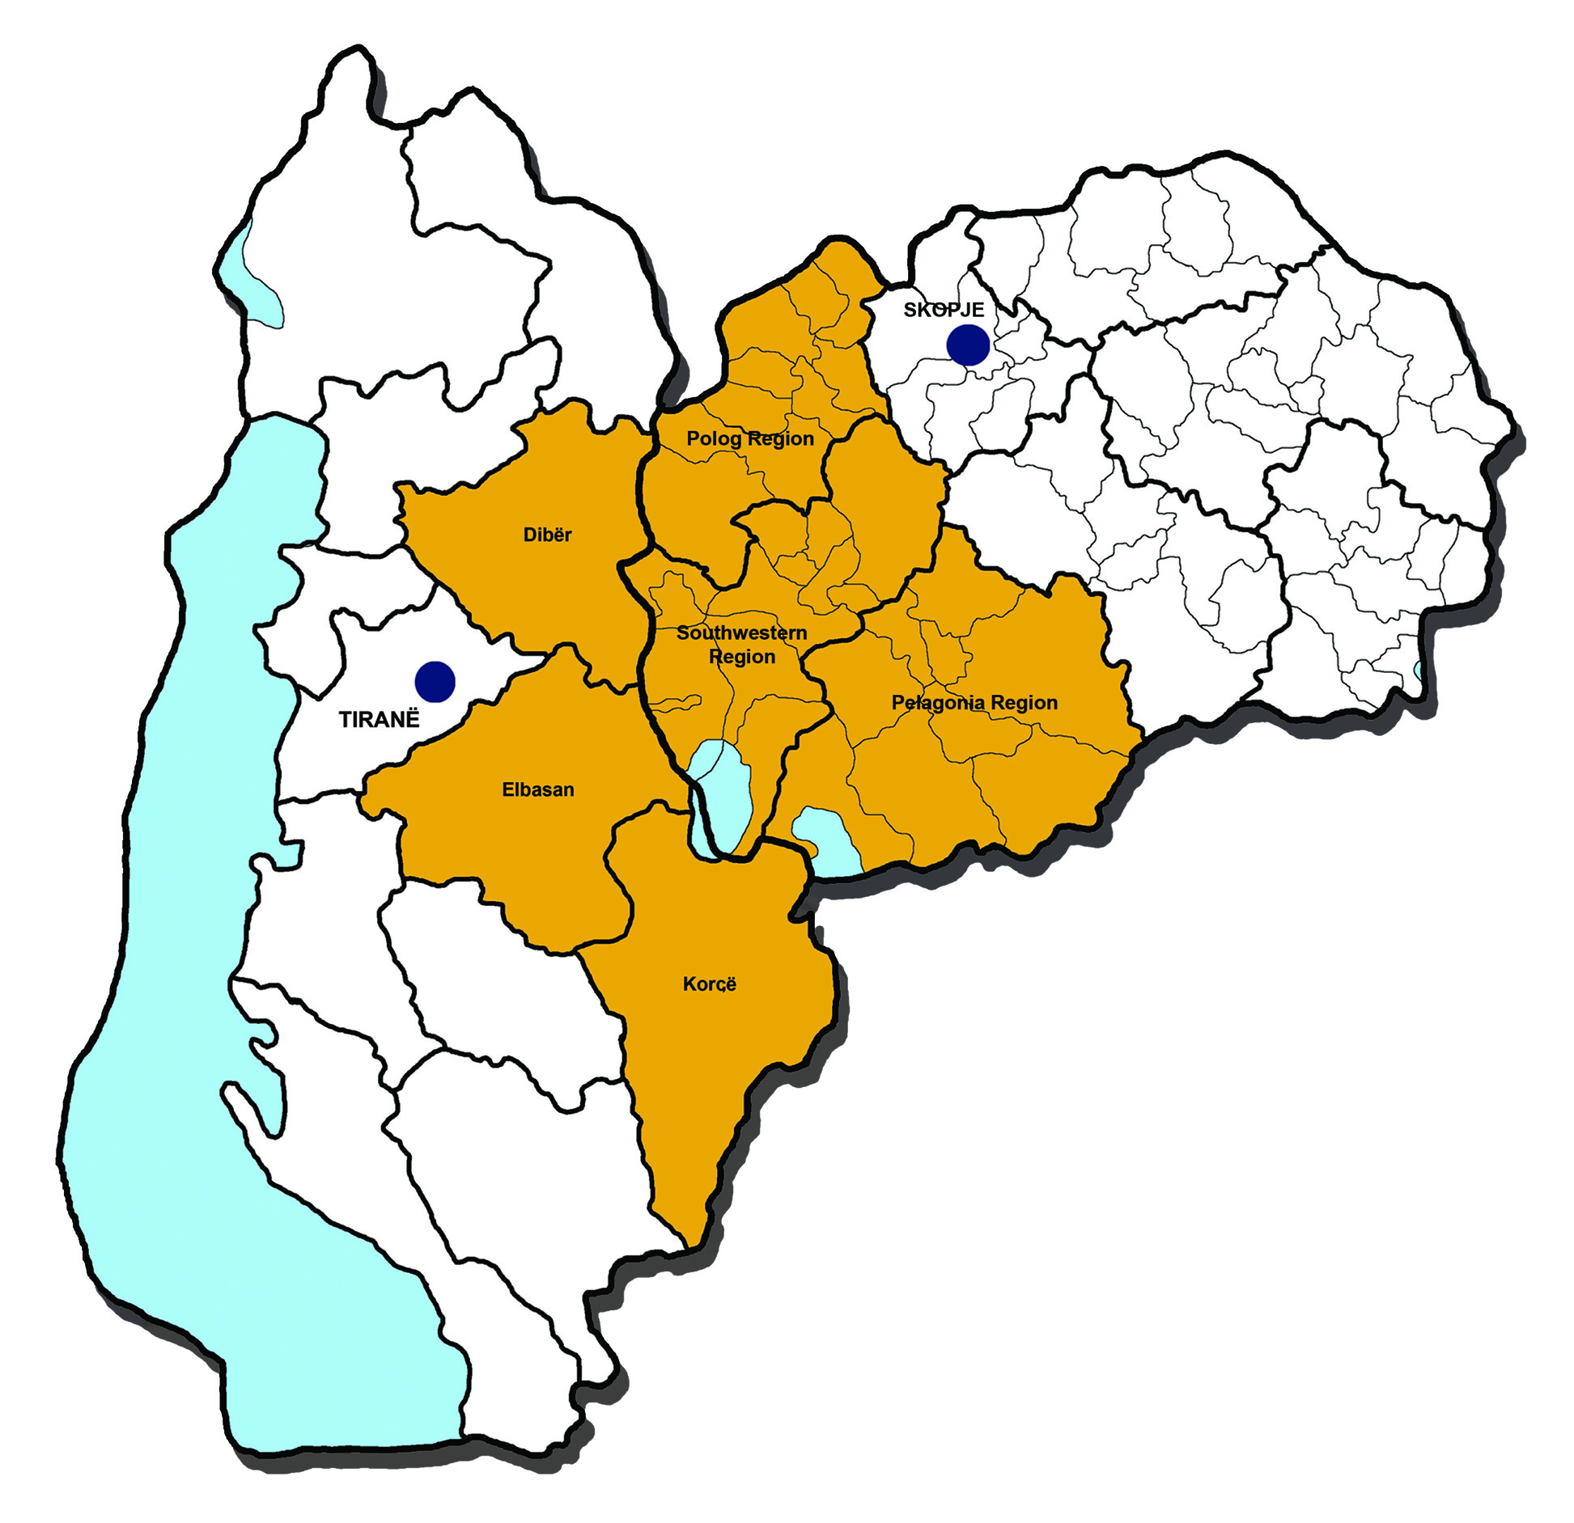

2.1 Situation Analysis – Synopsis

The Programme Area is characterised by rich natural resources, ethnic diversity and similar culture but different languages spoken. Most importantly however the border areas in the former Yugoslav Republic of Macedonia and Republic of Albania feature different economic legacy that determines rationale and potential for co-operation between people and institutions across the border for better integration and social and economic cohesion of the region.

This Synopsis distinguishes between general and demographic, economic and social cohesion aspects that inform the Strategy for 2014-2020 CBC intervention while a more detailed situation and SWOT analysis are annexed to the Programme document.

General and Demographic Aspects

- Nature and environment are rich in mountains, hilly areas intersected with rivers, valleys and lakes. The region features three big water reservoirs in the region: Lake Ohrid, Prespa and Debar, surrounded by a National Park and creating favourable conditions for the development of hydro energy in which the two countries had already invested. Environmentally sensitive areas are endowed with tourism development opportunities and the region accounts for almost half the forests in the both countries.

- The Programme Area features two Pan-European transport corridors: Corridor VIII and Branch D of Corridor X that open up economic opportunities along the two transport routes but also create challenges in terms of environment and infrastructure maintenance.

- The two countries feature almost equal economic development level and enjoy continuous improvement in bilateral relations and increase in the exchange of goods and services. The former Yugoslav Republic of Macedonia received an EU candidate country status while Republic of Albania’s application is subject to further progress of public administration reform and revision of the parliamentary rules and procedures.

- Both countries enjoy positive natural increase rates but the number of population is growing faster in Republic of Albania than in the former Yugoslav Republic of Macedonia. The Programme Area however experiences negative trends except for Polog and Southwest regions of the country. These two suffer from outward migrations that may contribute to depopulation. On average population density index is similar on both sides of the border but very low individual density figures for Dibra and Korca districts (prefectures) denote their rural and peripheral character.

- The Programme Area population is relatively young (36 years) but Pelagonia with 40 years of median population age is distinct.

Economic Cohesion

- Regional disparities in the both countries in terms of GDP per capita are considered moderate in general but the Programme Area features regions that clearly lag behind; these are: Polog in the former Yugoslav Republic of Macedonia and Dibra in Republic of Albania (respectively: 47% and 62% of the national figure).

- The structure of economy determined by GVA is different on both sides of the border. While Republic of Albanian regions rely on agriculture, forestry, fishing and wholesale and retail markets, the regions on the territory on of the former Yugoslav Republic of Macedonia feature more developed industry, construction and services markets. These, however, do not translate into significantly higher GDP per capital figures and indicate low competitiveness levels of those sectors and industries.

- Low competitiveness is reflected in low levels of internationalisation of the Programme Area’s economy. Only Pelagonia in the former Yugoslav Republic of Macedonia and Elbasan in Republic of Albania evidence an outstanding position in foreign trade, mainly due to mining industry, while other regions play insignificant role.

- Entrepreneurship evidenced by density of SMEs in relation to the size of population is at very low levels, which is an issue of high concern. Complicated and long-lasting administrative regulations for foreign trade are considered as red tape, hampering trade opportunities.

- Employment rates are low in the former Yugoslav Republic of Macedonia and significantly higher in Republic of Albania but for the latter country high employment rates result from subsistence and low-scale agricultural production that provide a form of social security for the bulk of the rural population and work as a buffer against high rates of registered unemployment.

- The Programme Area has high tourism potential but these opportunities are tapped into mainly on the former Yugoslav Republic of Macedonia side of the border.

- Rural economy is fragmented but to a much higher degree in Republic of Albanian Programme Area and small agricultural holdings have difficulties in accessing markets. Production is moderately diversified and the range of main agricultural produce on both sides of the border is more complementary than competing.

- Transport infrastructure is underdeveloped and this concerns both, local roads and main roads of the Corridor VIII.

Social Cohesion

- The Programme Area features vibrant ethnic minorities: Republic of Albanians, Roma people, Turks and others.

- Unemployment levels are very high for the former Yugoslav Republic of Macedonia and relatively low in Republic of Albania. For the latter one this occurrence is caused by high employment (mostly informal) in agricultural holdings.

- Workers’ net salaries are on similar levels.

- Republic of Albanian Programme Area experiences digital exclusion. The use of computers and of the Internet is at unacceptably low levels.

- Access to primary education is balanced but there is an evidenced strain on higher secondary education in Dibra region. This prefecture also experiences the highest brain drain in the whole Programme Area.

- There is no specific data on RDI but there is virtually lack of co-operation between education institutions in both countries, and research, development and innovation area is not explored.

- Poor levels of waste management, paired with high intensity of mining, are a major environmental concern. This relates to solid waste disposal and lack of waste water treatment in the majority of the Programme Area.

- Civil society organisations are existent in the Programme Area however their financial standing is weak. In addition to that Republic of Albanian NGOs experience difficulties with registration procedure and their legitimacy is consequently hampered.

- Healthcare infrastructure is underdeveloped and, especially in the Republic of Albanian Programme Area, difficult to access.

2.2 Main findings

Socio-economic analysis combined with SWOT consideration identified key problem nodes for the Programme Area. These are:

- Low levels of economic activity (performance and productivity);
- Linked to that mismatch of supply and demand on labour market;
- Unstructured approach to public investments and joint environmental protection activities and planning.

The three main problem nodes are further broken down into sub-nodes to reflect mainstream cause-effect relationship that provides a strategic context and rationale for the CBC intervention areas. The problem (or decision) tree logic is depicted below.

In addition to those strategic nodes weak institutional capacity of local self-government units and civil society organisations appears as a cross-cutting problem node and issue of concern, which manifests in deficient planning and allocation of scarce resources.

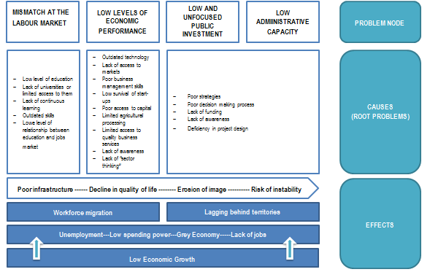

Causes (or root problems) in the chart above are identified through Situation and SWOT analysis. They are recognised as those that have cross-sectoral or cross-thematic character and thus relate to three of the thematic priorities for assistance for territorial cooperation as identified in Annex III to the IPA II Regulation:

- Enhancing competitiveness, business, trade and investment;
- Protecting environment, promoting climate change adaptation and mitigation, risk prevention and management;

Besides the problem nodes tourism and cultural heritage have been identified as an important economic opportunity and a vehicle to further boost people-to-people contacts and exchange. This relates to another Thematic Priority for assistance for territorial cooperation in Annex III to the IPA II Regulation being encouraging tourism and cultural and natural heritage.

All thematic priorities were individually ranked by stakeholders in the CBC Programming process (municipalities, NGOs, line Ministries, public utility companies and other public entities, etc.) according to the perceived importance of the themes and topics.The ranking represents a significant programming feedback that reflects on bottom-up approach and is built on partnership principle. This however does not consider policy or resource limitations that are only applied trough coordination mechanism and principle (Section 3).

Section 3: Programme Strategy

The Strategy acknowledges priorities communicated by Programme stakeholders (Section 2.2) which have been subsequently filtered and screened by the CBC Operating Structures and Joint Task Force in charge of the programing effort thus applying coordination principle. Strategic choices were made considering the following overarching principles:

Coherence - Thematic Priorities were not altered and are those that are communicated in the Annex III to IPA II Regulation and respectively to the Multi-country Strategy Paper;

Partnership - appropriate Priorities are selected based on feedback from organisations representing regional, local, urban and other public authorities, economic and social partners as well as civil society, environmental partners, non-governmental organisations and organisations responsible for promoting equality;

Concentration - Strategy provides a relevant and efficient focus of limited resources and intervention based on the social and economic specifics of the Programme Area that focuses on selected themes, and on objectives and measures of fundamental significance from the socio-economic cohesion and desired development perspective.

Complementarity with the National Programme – the programme complements and enhances the national strategies as set out in the Country Strategy Papers by supporting regional and territorial cooperation.

3.1 Rationale - Justification of the selected intervention strategy

The proposed Strategy content flows from:

- Situation and SWOT analysis;
- Identified problem nodes and strategic opportunity; and
- Ranking of Thematic Priorities according to their importance for the Programme Area: Encouraging tourism and cultural and natural heritage, Enhancing competitiveness, business, trade and investment and Protecting environment, promoting climate change adaptation and mitigation, risk prevention and management.

A more balanced, inclusive and sustainable socio-economic development in the Border Area is stimulated is the Programme main strapline and its Overall Objective, given the medium term perspective if the proposed intervention.

The Programme seeks synergies with Specific Objectives of IPA II and Country Strategy Papers with regard to: support for the development of civil society and social dialogue, fostering employment and developing human capital, social and economic inclusion and territorial co-operation.

Table 1: Synthetic overview of the justification for selection of thematic priorities

Selected thematic priorities | Justification for selection
Encouraging tourism, culture and natural heritage (TP4 IPA II Regulation) | Builds on identified strategic opportunities related to the increasing importance of tourism as an economic opportunity while fostering cultural exchange and promotion of natural heritage will sustain people-to-people and civil society dialogue between institutions.
Enhancing competitiveness, business, trade and investment (TP7 IPA II Regulation) | Seeks to address low employment levels in the Programme Area. This will be tackled through the improvement of access to markets, increased use of ICT tools, including e-commerce, and more efficient exploitation of value chain opportunities in the Border Area.
Protecting environment, promoting climate change adaptation and mitigation, risk prevention and management (TP2 IPA II Regulation) | Aims to respond to specific needs of one of the most neglected policy sectors. In CBC context this will address issues of the promotion of cleaner and greener economy, more responsible and sustainable use of natural resources, climate resilience small-scale support infrastructure (against flooding and wildfires) and soil erosion in the mountainous border area.

Technical Assistance will ensure sound Programme management throughout its entire lifecycle and capacity development of relevant Programme stakeholders. The financial allocation towards this Priority is 10% of the Programme budget.

Indicative budget allocation across Thematic Priorities is a consensus between concentration principle combined with balanced distribution of funds. Consideration is also given to capital intensity of likely projects and the actual Thematic Priority ranking where tourism, cultural and natural heritage were the most preferred topics for support.

Thematic Priority | Budget Distribution of the EU funds (%)
1. Encouraging tourism, culture and natural heritage (TP4) | 31.5
2. Enhancing competitiveness, business, trade and investment (TP7) | 31.5
3. Protecting environment, promoting climate change adaptation and mitigation, risk prevention and management (TP2) | 27.0
4. Technical Assistance | 10.0
TOTAL | 100

The principle of smart, sustainable and inclusive growth is recognised as a cross-cutting issue and is applied to all Programme Thematic Priorities and their objectives.

The proposed Strategy also builds on key findings and recommendations of the draft CBC the former Yugoslav Republic of Macedonia-Republic of Albania evaluation report for the years 2007-2013. Accordingly, the following issues are considered:

- Support towards joint small-scale infrastructure projects that do not require sophisticated and complex studies and designs;
- Assistance towards projects aimed at the development of studies and designs for funding from domestic resources and other donors;
- Strategic focus on more robust actions to bring about more tangible impact;
- Improved and more strategic orientation of the JTS under Technical Assistance, especially in regard to capacity building and awareness raising among potential beneficiaries situated in the Programme Area and not outside to ensure their readiness to apply Lead Partner Principle;
- Strengthening of the strategic co-ordination role of the OSs;
- Orientation of the JTS on networking and project experience sharing between organisations from the Programme Area;
- Fostering more active role of the JTS in Programme monitoring and development of tools and manuals internally and for external users;
- Enhanced planning and implementation of the JTS operations.

Recommendations and lessons learned from two interim evaluations on CBC programmes focused on governance structures and on the performance of the assistance have been taken into account:

- The programming document should be subject to (1) public consultation and clearly to reflect the consultation process including an overview of who took part and the results of the consultation process; (2) to include the cross-cutting issues in all the programming documents and (3) to carry out an ex ante evaluation (to be included in the document).
- With regard to organisational issues the programming structures should: (1) carry out a human resource management audit and training needs assessment; (2) transfer tasks to the JTSs including preparation for the TA grants; (3) support the implementation of monitoring and evaluation systems.

3.2 Description of Programme Thematic Priorities

The description of each Thematic Priority (TP) is arranged in the form of Priority Data Sheet with contents and structure alike per each priority while Technical Assistance Priority has a distinct composition.

The Programme Thematic Priority numbering is sequenced according to the TP importance ranking computed in the course of the programming exercise with reference to specific TP numbering identified in the IPA II Regulation.

The figure below outlines that Programme intervention logic and intersection of individual Priority with cross-cutting and horizontal issues.

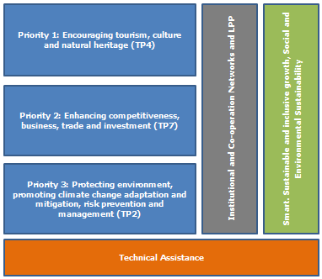

Since the programming perspective 2014-2020 is more result-oriented than the IPA 2007-2013 framework all result indicators outlined in the data sheets below are intended to inform the selection of operations and projects to be supported. These shall directly contribute to the indicators defined for the Programme.

The content of intervention outlined below considers observations and constructive comments produced during public consultation events held in the Programme Area in the period December 2013-March 2014.

Thematic Priority 1: Encouraging tourism, culture and natural heritage (TP4)

Thematic Priority Outline and Strategic Reference

Europe is the world’s no. 1 tourism destination with cultural tourism and a large number of major sites and a strong flow of international and domestic visitors. Tourism policies will need to adapt to these trends and develop a quality offer promoting local cultures and traditions and paying attention to sustainable aspects: preservation of the heritage, of the landscape and of the local culture. The Programme Area aims to tap into strategic opportunities arising from the broader potential of the entire continent, which is in line with the concept of sustainable and cultural tourism promoted by DG Enterprise and Industry.

Tourism has been recognised as one of the priority economic opportunities that are of interest of the CBC population. Although hospitality industry is unevenly distributed in the Programme Area, the industry in both countries is growing. At present, tourism related activities are the main source of income for the population in the Ohrid and Prespa regions in summer months but there is underutilised potential for the development of cultural, adventure and more sustainable tourism across the CBC region.

Cooperation between different institutions and organisation in the CBC region is increasing but yet there is a virtual absence of sustainable joint initiatives on a larger scale. The activities encompassed in this Thematic Priority will also support cooperation between institutions based on valorisation of the heterogeneous offer and potential of different cultures and traditions present in the area and people-to-people actions. These should contribute to address challenges like: preservation of natural and cultural resources, promoting the wellbeing of local communities, improving the quality of tourism jobs, limiting environmental impact of tourism related transport, etc.

Specific Objective

This Thematic Priority’s Specific Objective seeks to develop the potential of tourism by promoting cultural heritage and values (SO 1.1).

The Thematic Priority will encourage diversification of the supply of tourist services and products. By supporting projects promoting sustainable thematic tourism products the Programme will strengthen trans-national cooperation with regard to sustainable tourism, encourage a higher involvement of small and micro enterprises and local authorities and stimulate competitiveness of the tourism industry by means of an enhanced focus on the diversification of sustainable thematic and cultural tourism products. The Thematic Priority also seeks to uplift skills of staff engaged in hospitality industry, including vocational training to address deficiency of skills for diversified tourism offer, e.g. for tourist guides and trainers specialised in winter sports, mountain sports, rural and adventure tourism, hotel services staff, etc.

Expected Results

This Thematic Priority aims to achieve the following results:

    - Business opportunities for local service providers and operators in the field of tourism are increased;
    - Mutual co-operation, understanding and respect of cultural heritage and values are furthered.

Indicative Activities and Target Groups

The indicative Activities and Target Groups are arranged in the table below.

Indicative Activities | Beneficiary Target Groups
1.1.1.1 Design, development and promotion of joint tourism products and services and small scale investment in public tourism infrastructure | - Local and regional government units  - Tourist service providers  - NGOs, CSOs  - National parks  - Chambers of commerce  - Networks/clusters of SMEs
1.1.1.2 Training for uplifting of skills in hospitality industry | - VET educational institutions  - Tertiary education institutions  - Other formal and non-formal educational and training institutions  - NGOs, CSOs  - Networks/clusters of SMEs
1.1.2.1Restoration/reservation, preservation, cleaning and maintenance of cultural and historical sites and associated built environment | - Local and regional government units  - Tourist service providers  - NGOs  - Cultural institutions (museums, libraries, orchestras, etc.)  - Hospitality industry operators (SMEs)
1.1.2.2 Support to joint cultural events | - Local and regional government units  - NGOs  - Education institutions (all levels)  - Cultural institutions (museums, libraries, orchestras, etc.)  - Residents and their organisations

Thematic Priority Implementation Performance Indicators

Specific Objective result 1.1.1: Business opportunities for local service providers and operators in the field of tourism are increased
Output  indicator | Description | Baseline value | Target value  (2017) | Target value  (2020) | Data source | Reporting  interval
No. of new/improved services/products | New services/products improved | 0 | 4 | 10 | Monitoring system | Annually, from  implementation date
No. of trainees | Training of people in hospitality industry | 0 | 50 | 500 | Monitoring system | Annually, from  implementation date

Result indcator | Description | Baseline value | Target value  (2017) | Target value  (2020) | Data source | Reporting  interval
No. of tourists using new/improved services | Tourists using the new improved cervices | 0 | 2,000 | 5,000 | Monitoring system | Annually, from  implementation date

Impact /outcome  indicator | Description | Baseline value* | Target value  (2020)** | Data source | Reporting  interval
Average length of tourist stay (overnights) | Average number of overnight stays per registered tourist | 2,8 overnight stays (2013 data including statistics from both countries for the eligible area) | Increase by  1 overnight | State Statistical Office and  INSTAT | Annually, from  implementation date
* Source: State Statistical Office, http://www.stat.gov.mk/prikaziPublikacija_1.aspx?rbr=483 . Data were taken from the Quarterly Survey of Enterprises in Albania, 2013
** Cumulative

Specific Objective result 1.1.2: Mutual co-operation, understanding and respect of cultural heritage and values are furthered

Output  indicator | Description | Baseline value | Target value  (2017) | Target value  (2020)* | Data source | Reporting  interval
No. of cultural heritage sites improved | Improvement of cultural heritage sites | 0 | 2 | 4 | Monitoring system | Annually, from  implementation date
No. of events organised | Organisation of joint cultural events | 0 | 10 | 20 | Monitoring system | Annually, from  implementation date
New digitised collections/library funds created | New digitised cultural collections/library funds created | 0 | 2 | 5 | Monitoring system | Annually, from  implementation date
* Cumulative

Result indcator | Description | Baseline value | Target value  (2017) | Target value  (2020) | Data source | Reporting  interval
No. of visitors in cultural heritage establishments | People visiting the cultural establishments | TBD* | Increase by 7% for sites and subjects of Programme intervention | Increase by 15% for sites and subjects of Programme intervention | Monitoring system  State Statistical Office and  INSTAT | Annually, from  implementation date
* Baseline value concerns performance of beneficiaries before intervention; respective figures to measure baseline value shall be provided in application by applicant

Impact/outcome  indicator | Description | Baseline value | Target value  (2020)* | Data source | Reporting interval
% of stakeholders involved in activities | Ratio of relevant stakeholders who got involved in cultural activities under the prgramme | 1465* | Increase by 10% in comparison with 2007-2013 | Monitoring system | Annually, from  implementation date
* Annual Implementation Report (AIR) 2013

Implementation Modalities

The activities envisaged under this Thematic Priority will be implemented through grant scheme modalities based on Call for Proposals methodology within PRAG regime.

The activity aimed at upgrading of skills of hospitality industry personnel must include representatives of the industry as stakeholders in each project proposal.

A broad range of potential beneficiaries is envisaged under this Thematic Priority. Significant number of small scale projects stimulating people-to-people and institution-to-institution cooperation is expected only for Activity 1.1.2.2.

Activities 1.1.1.1 and 1.1.2.1 will enforce projects with more significant long-term impact such as small scale tourism infrastructure and refurbishing of historical and cultural monuments..

The scope of intervention under this Thematic Priority may partly intersect with support provided through Thematic Priority 2, especially in regard to private undertakings being eligible applicants and beneficiaries. In this respect the following demarcation line is drawn up: Thematic Priority stakeholders (partners or associates according to PRAG modalities) falling under SME category must fall under NACE section I: Accommodation and food service activities.

Two scenarios are envisaged to provide grant support:

- Activities 1.1.1.1, 1.1.2.1 will be supported in mid-term perspective as they require more extensive facilitation and project mobilisation and project development support than other Activities. Thus they shall only be included in the 2nd and 3rd round of CfP’s whilst Activities 1.1.1.2 and 1.1.2.2 will be supported through the 1st and 3rd round of CfP’s.

- The entire Thematic Priority will be implemented through one CfP (exception can be granted for Activity 1.1.2.2 that can repeat in each CfP’s if appropriate to reduce entry barriers for applicants with lower financial capacity).

A single call for proposals may cover more than one Thematic Priority. When appropriate and possible the call for proposals shall include budget allocations from different annual financial allocations in order to promote larger scale projects.

Thematic Priority 2: Enhancing competitiveness, business, trade and investment (TP7)

Thematic Priority Outline and Strategic Reference

High unemployment, low levels of employment and value added in the Programme Area economy is an issue of serious concern. Thus, promotion, sustaining and creation of jobs and alternative sources of income appear as one of the main targets of socio-economic development policy in the CBC region in these circumstances.

The Thematic Priority will seek to support access to markets of economic operators in all key sectors of the Programme Area economy, increase the use of ICT tools and technologies and tap into unexploited value chain opportunities, including those in rural economy. These are expected to contribute to the increased competitiveness, development of trade and new investments in the Programme Area.

The Activities of this Thematic Priority aim to address limited number of strategic opportunities related to competitiveness, which remains one of the key pillars of the Europe 2020 Strategy. The scope of the proposed intervention is fully consistent with IPA II sector approach: Policy Area A – Transition process and Institution Building, sector: Private Sector Development and Thematic Objective 3 of Structural Funds intervention: Competitiveness of SMEs.

Specific Objective

This Thematic Priority concentrates on the strengthening of the SME productive capacity and access to markets (SO 2.1).

The intervention will focus on the improvement and awareness raising of opportunities deriving from existing economic value chain openings, support towards product and process quality certification required in international markets and ampler use of modern sales techniques, including e-commerce. In order to boost rural economy and its strategic opportunities a campaign to open/develop organised fresh produce markets will be provided.

Expected Results

The expected result associated with the Thematic Priority’s Specific Objective is:

    - The SMEs and start-ups awareness and capacity to tap into new markets and value chains are enhanced.

Indicative Activities and Target Groups

The indicative Activities and Target Groups are grouped in the table below.

Indicative Activities | Beneficiary Target Groups
2.1.1.1 Assistance to SMEs and start-ups for internationalisation and business partner finding | - Local and regional government units  - Business member organisations (e.g. chambers of commerce/crafts)  - Associations of SMEs, their clusters, groups and networks  - RDI organisations and higher education institutions
2.1.1.2Investment in small-scale cross-border market and trading facilities | - Local and regional government units  - Centres for Development of Planning Regions  - Public enterprises (owned in 50%+ by public bodies) - in case of development of cross-border markets and trade facilities (including fresh produce markets)  - Associations of SMEs, their clusters and business-member organisations (e.g. chambers of commerce/crafts)  - Farmers associations

Thematic Priority Implementation Performance Indicators

Output  indicator | Description | Baseline value | Target value  (2017) | Target value  (2020)* | Data source | Reporting  interval
No. of foreign trade activities | Activities targeting the external market | 0 | 5 | 10 | Monitoring system | Annual
No. of businesses participating in new foreign trade activities | No. of busi-ness benefit-ing from new foreign trade activities | 0 | 30 | 50 | Monitoring system | Annual
No. of SMEs with new conformity certificates awarded (ISO, HACCP, etc.) | SMEs having new conformity certificates | 0 | 8 | 20 | Monitoring system | Annual
No. of new markets and trade facilities developed through agreements | No of agreements with new markets and trade facities | 0 | 1 | 3 | Monitoring system | Annual
* Cumulative

Result indicator | Description | Baseline value | Target value  (2017) | Target value  (2020) | Data source | Reporting  interval
Share of export value of goods and services (%) | Ratio of ex-ports on goods and services in relation to total trade | TBD* | Increase by 2% | Increase by 5% | Monitoring system  State Statistical Office and  INSTAT | Annual
Turnover of businesses | Increase in the total sales of a company over a stated period | TBD* | Increase by 3% | Increase by 8% | Monitoring system  State Statistical Office and  INSTAT | Annual
* Baseline value concerns performance by beneficiaries/target group before intervention; respective figures to measure baseline value shall be provided by applicant in project application form

Impact/outcome indicator | Description | Baseline value | Target value  (2020)* | Data source | Reporting interval
Gross Value Added by Sector | Increased percentage of the value of goods and services produced in the economic sector within the  geographical area | TBD* | Increase by 2% in comparison with 2013 | State Statistical Office and  INSTAT | Annual

* The data will be calculated after the statistical offices provide the necessary information

Implementation Modalities

The entire Thematic Priority 2 Activities will be implemented through grant schemes.

Aid granted to individual businesses must comply with EU laws: i) State Aid granted under GBER or ii) de minimis aid with max. aid ceiling up to 85% to ensure minimum co-financing required for IPA.

Demarcation line between Activities implemented under this Thematic Priority and Thematic Priority 1 is defined in regard to eligibility of applicants: SMEs and their networks benefitting from Thematic Priority 2 intervention must not fall under NACE section I: Accommodation and food service activities.

There are two options envisaged to provide intervention under this Thematic Priority depending on the ultimate features of financial envelope:

- Activity 2.1.1.1 could be supported in the 1st and 3rd round of CfP’s while Activity 2.1.1.2 during the 2ndor 3rdCfP’s (to avoid clash in one CfP with Activity 1.1.2.1 that is also expected to consume large portions of funding - these projects are expected to be significant in size and longer in duration than any other initiatives).

- The entire TP could be implemented through one CfP.

Thematic Priority 3: Protecting environment, promoting climate change adaptation and mitigation, risk prevention and management (TP2)

Thematic Priority Outline and Strategic Reference

The Programme Area is characterised by rich and diversified environment and nature and is recognised as a clean and green territory in general. The region however lacks environment protection infrastructure, strategies and practices for early risk recognition, prevention and management. The border area is prone to adverse weather and climatic phenomena, especially heavy storms and rainfalls resulting in local flooding and landslides damaging roads, private properties and agricultural land. In a dry season wildfires compromise rural economy and crops production. Climate resilience is thus one of the issues to be addressed through this Thematic Priority.

In addition to that improvements in deficient solid waste collection, waste management and treatment and soil erosion preventive practices are considered as a priority intervention areas in the CBC region.

“Living well, within the limits of our planet” is the main strapline of a new Environment Action Programme by 2020 to be proposed by the Commission. This CBC Programme Thematic Priority builds on that heading and is consistent with IPA II Policy Area B: Regional Development, Sector: Environment and Climate Change and Thematic Objectives 5 & 6 of Structural Funds intervention: Climate change promotion, adaptation, risk prevention and management & Protection of environment and promotion of resource efficiency.

The Thematic Priority Activities encompass both, “soft projects” aiming at improvement of the awareness and promotion of more sustainable use of resources, greener economy, as well as supporting small scale investments in environmental protection infrastructure that is considered to have a significant CBC impact and produce demonstration effect. The intervention also seeks to address low financial and institutional capacity of public utility companies and promotion of sustainable farming practices and agriculture production methods.

Specific Objective

The awareness of a greener economy, cleaner environment and climate change is enhanced remains the headline Specific Objective of this Thematic Priority (SO 3.1).

The Thematic Priority has clearly a spatial dimension requiring place-based approach as certain border territories are distinctive, and will concentrate on building of awareness and knowledge, integration of communities and target groups and implementation of real measures to address the issues contemplated in the section above. Specific focus will be directed towards timber forest product processing and water supply.

Expected Results

This Thematic Priority shall achieve the following results:

    - Awareness and knowledge of sustainable use of natural resources and environment is fostered;
    - Public infrastructure vulnerable to floods, soil erosion and wildfire is upgraded.

Indicative Activities and Target Groups

The indicative Activities and Target Groups are arranged in the table below.

Indicative Activities | Beneficiary Target Groups
3.1.1.1 Promoting and supporting sustainable use of natural resources and environment | - Local and regional government units  - Centres for Development of Planning Regions  - Public utility companies  - National parks  - CSOs, NGOs  - Chambers of commerce  - RDI organisations  - Associations of CBC residents, especially in rural areas  - Farmers associations  - Primary, secondary and tertiary education and research institutions  - Networks of SMEs
3.1.2.1 Promoting investments in small-scale infrastructure for disaster resilience and environmental protection | - Local and regional governments  - Centres for Development of Planning Regions  - National and regional centres for disaster management and monitoring  - Public utility companies  - Farmers organisations  - CSOs, NGOs  - Chambers of commerce  - Associations of CBC residents, especially in rural areas

Thematic Priority Implementation Performance Indicators

Specific Objective result 3.1.1: Awareness and knowledge of sustainable use of natural resources and environment is fostered

Output  indicator | Description | Baseline value | Target value  (2017) | Target value  (2020)* | Data source | Reporting  interval
No. of awareness campaigns on sustainable use of resources and environment | New public campaigns on environmental issues at project level | 0 | 5 | 12 | Monitoring system | Annual
No. of improved waste management systems and value chains within the area | No of waste management systems and value chains upgraded within the area | 0 | 3 | 6 | Monitoring system | Annual
No. of site cleaning actions | No of initiatives implemented for site cleaning at project level | 0 | 4 | 8 | Monitoring system | Annual
* Cumulative

Result indicator | Description | Baseline value | Target value  (2017) | Target value  (2020) | Data source | Reporting  interval
% of population in CBC area made aware of sustainable use of natural resources and environment in key sectors | Population rate informed on the sustainable used of natural resources and environmental issues | TBD* | 1% (aprox. 14,000) | 3.5% (approx. 50,000) | Monitoring system | Annual
% of all businesses and organisations participating in joint actions in water and waste management | Ratio between those participating in joint actions and all those existing bodies in the area | TBD* | 5% | 10% | Monitoring system | Annual
* Baseline value concerns performance by beneficiaries/target group before intervention; respective figures to measure baseline value shall be provided by applicant in project application form

Impact /outcome  indicator | Description | Baseline value | Target  value  (2020) | Data source | Reporting  interval
Use of water by households and businesses | Percentage of water losses reduced | TBD* | Decrease of water use by 10% | Monitoring system  State Statistical Office and  INSTAT | Annual
% of waste collected for recycling | Ratio between the recycled waste in relation to the amount collected | TBD* | Increase in waste collected for recycling by 15% | Monitoring system | Annual
% of waste collected for recycling | Ratio between the number of closed illegal dumpsites in relation to the original existing number of dumpsites | TBD by JTS with municipalities, ministry in charge of environment | Decrease of number of illegal dumpsites by 10% | Monitoring system | Annual
* Baseline value concerns performance by beneficiaries/target group before intervention; respective figures to measure baseline value shall be provided by applicant in grant application form

Specific Objective result 3.1.2: Public infrastructure vulnerable to floods, soil erosion and wildfire is upgraded

Output  indicator | Description | Baseline value | Target value  (2017) | Target value  (2020)* | Data source | Reporting  interval
No. of projects supported | Total figure of new projects supported under this objective | 0 | 5 | 12 | Monitoring system | Annual
No. of flood and wildfire protection facilities equipped | No. of flood and wildfire protection facilities newly equipped | 0 | 0 | 2 | Monitoring system | Annual
No. of awareness raising campaigns | No. of new awareness raising campaigns | 0 | 2 | 5 | Monitoring system | Annual
Number of households/farms and other organisations benefitting from new activities | Number of households/farms and other organisations benefitting from new activities | 0 | 100 | 250 | Monitoring system | Annual
* Cumulative

Result  indicator | Description | Baseline value | Target value  (2017) | Target value  (2020) | Data source | Reporting  interval
Length of roads protected | Ratio of the no. of kms protected in roads exposed to natural disasters in relation to the no. of kms of roads in need of protection | 0 | 3% | 10% of roads exposed to risks | State Statistical Office and  INSTAT  Monitoring system | Annual
Size of agricultural area protected | Ratio of the surface of agricultural land protected in relation to the total surface of land in need of protection | 0 | 2% | 5% of land exposed to risks | State Statistical Office and  INSTAT  Monitoring system | Annual
Size of forestry area protected | Ratio of the surface of the forest area protected in relation to the total surface of the forest area in need of protection | 0 | 2% | 5% of forests exposed to risks | State Statistical Office and  INSTAT  Monitoring system | Annual

Impact/outcome  indicator | Description | Baseline value | Target value  (2020)* | Data source | Reporting interval
Size of CBC area covered by activities | Surface of the CBC eligible are covered by project activities | 0 | 3% | Monitoring system | Annual

Implementation Modalities

Activities will be implemented through grant funding, following PRAG grant delivery modalities.

Implementation of the Thematic Priority will require the involvement of different groups of stakeholders active on local and regional level. It is expected that over time significant impact will be met by motivating local authorities and public communal companies in the CBC region to take an active role in implementation of the programme: small scale environment investments will be designed within their mandate through transparent procedures of public procurement, and would not require preparation of detailed and expensive project documentation financed from the Programme’s funds.

Grant funding could be offered according to the following alternative scenarios:

- Both Activities could be implemented in parallel.
- Activity 3.1.1.1 could be implemented during the 1st and 3rd round of calls for proposals while Activity 3.1.2.1 - in the course of the 2nd round of calls for proposals.

Technical Assistance

The specific objective of the technical assistance is to ensure the efficient, effective, transparent and timely implementation of the cross-border cooperation programme as well as to raise awareness of the programme amongst national, regional and local communities and, in general, the population in the eligible programme area. It also supports awareness-raising activities at country level in order to inform citizens in both IPA II beneficiaries. Moreover, as experience has shown under the programming cycle 2007-2013, this priority will also reinforce the administrative capacity of the authorities and beneficiaries implementing the programme with a view to improve ownership and suitability of the programme and projects’ results.
The technical assistance allocation will be used to support the work of the national Operating Structures (OS) and of the Joint Monitoring Committee (JMC) in ensuring the efficient set-up, implementation, monitoring and evaluation of the programmes as well as an optimal use of resources. This will be achieved through the establishment and operation of a Joint Technical Secretariat (JTS) based on the territory of the former Yugoslav Republic of Macedonia and an Antenna Office on Republic of Albania. The JTS will be in charge of the day-to-day management of the programme and will be reporting to the OS and JMC.

Intended results:
The administrative support to the Operating Structures (OS) and Joint Monitoring Committee (JMC) of the programme is enhanced.
This priority will secure a smooth programme implementation during all its phases. It includes the availability of the financial means and the deployment of qualified staff in charge of assisting the Operating Structures and the Joint Monitoring Committee, as well as establishing and enforcing management, monitoring and control mechanisms and procedures. If required, it will also contribute to the preparation of the successive financial cycle (2021-2027).
Result indicators:
Indicator | Unit | Baseline | Target 2022 | Source
Average share of beneficiaries satisfied with the  programme implementation support | Percentage | 0 | 60 % | Survey

The technical and administrative capacity for programme management and implementation is increased.
This priority will also provide opportunities for improving the competences and skills of the management structures of the programmes, as well as of the potential applicants and grant beneficiaries. Specific capacity building activities will be planned and executed on the basis of identified needs in the course of the implementation of the programme. As part of the lessons learned from the programme cycle 2007-2013, (i) an increased participation of the JMC members in the tasks stipulated under the IPA II legal framework will be expected; (ii) the capacity of potential applicants to develop sustainable cross-border partnerships will be enhanced; and (iii) the capacity of grant beneficiaries to satisfactorily meet the obligations of their contracts will be reinforced.
Result indicators:
Indicator | Unit | Baseline | Target 2022 | Source
Average increase in the number of proposals received within each consecutive call | percentage | 123 * | + 45% | AIR
Average increase in the number of concept notes that would qualify for further assessment | percentage | 59 | 10 % | AIR

The visibility of the programme and its outcomes is guaranteed.
The CBC programmes have been very popular in the eligible areas thanks, amongst other things, to the visibility actions undertaken during the 2007-2013 programme cycle. Looking at the number of applicants in subsequent calls, it has been noted that there is an increasing interest for cooperation initiatives. These achievements should be maintained and even improved during the implementation of the financial perspective 2014-2020. A variety of communication channels and publicity tools should be developed to ensure regular information between programme stakeholders and a wider audience.
Result indicators:
Indicator | Unit | Baseline | Target 2022 | Source
People participating in promotional events | Number | 1398* | 2000 | AIR
Visits to the programme website | Number | 40* | 700 | AIR
* AIR 2013
Type of activities:
A non-exhaustive list of potential activities covered by the technical assistance allocation would include:
- Establishment and functioning of the Joint Technical Secretariat and its Antenna.
- Organisation of events, meetings, training sessions, study tours or exchange visits to learn from best practice of other territorial development initiatives
- Participation of staff of the management structures in Western Balkans or EU forums
- Preparation of internal and/or external manuals/handbooks
- Assistance to potential applicants in partnership and project development (partners search forums etc.)
- Advice to grant beneficiaries on project implementation issues
- Monitoring of project and programme implementation, including the establishment of a monitoring system and related reporting
- Organisation of evaluation activities, analyses, surveys and/or background studies
- Information and publicity, including the preparation, adoption and regular revision of a visibility and communication plan, dissemination (info-days, lessons learnt, best case studies, press articles and releases), promotional events and printed items, development of communication tools, maintenance, updating and upgrading of the programme website, etc.
- Support to the work of the Joint Task Force in charge of preparing the programme cycle 2021-2026

Target groups and final beneficiaries (non-exhaustive list)
- Programme management structures
- Potential applicants
- Grant beneficiaries
- Final project beneficiaries
- Wider public
Implementation Modalities

Visibility and Communication Plan shall be produced in accordance with general IPA II requirements and best practice on transparency and equal treatment.

Beneficiaries shall be informed correctly and fully on the publicity regulations. Attention is given to visibility rules during the monitoring of project implementation.

The bodies involved in the implementation of the programme are responsible for ensuring that final beneficiaries carry out the information and publicity measures on the IPA II co-financed activities in line with the EU visibility guidelines.

Table 2: Overview of the programme strategy

Thematic priority (TP) | Specific objective(s) | Results | Indicators | Types of activities  (examples)
Thematic Priority 1: Encouraging tourism, culture and natural heritage (TP4) | This Priority’s Specific Objective seeks to develop the potential of tourism by promoting cultural heritage and values | 1.1.1 Business opportunities for local service providers and operators in the field of tourism are increased;  1.1.2 Mutual co-operation, understanding and respect of cultural heritage and values are furthered. | 1.1.1 No. of tourists using new/improved services.  No. of new/improved services/products.  No. of trainees.  Average length of tourist stay (overnights).  1.1.2 No. of visitors in cultural heritage establishments.  No. of cultural heritage sites improved.  No. of events organized.  No. of new digitized collections/libraries.  % of stakeholders involved in activities. | 1.1.1.1 Design, development and promotion of joint tourism products and services and small scale investment in public tourism infrastructure.  1.1.1.2 Training for uplifting of skills in hospitality industry.  1.1.2.1Restoration/reservation, preservation, cleaning and maintenance of cultural and historical sites and associated built environment.  1.1.2.2 Support to joint cultural events.
Thematic Priority 2: Enhancing competitiveness, business, trade and investment (TP7) | Strengthening of the SME productive capacity and access to markets | 2.1.1 The SMEs and start-ups awareness and capacity to tap into new markets and value chains are enhanced. | Share of export value of goods and services (%).  Turnover of businesses  GVA.  No. of new foreign trade activities.  No. of businesses participating in new foreign trade activities.  No. of SMEs with new conformity certificates awarded (ISO, HACCP, etc.).  No. of new markets and trade facilities developed through agreements. | 2.1.1.1 Assistance to SMEs and start-ups for internationalisation and business partner finding.  2.1.1.2 Investment in small-scale cross-border market and trading facilities.
Thematic Priority 3: Protecting environment, promoting climate change adaptation and mitigation, risk prevention and management (TP2) | Enhanced awareness of a greener economy, cleaner environment and climate change | 3.1.1 Awareness and knowledge of sustainable use of natural resources and environment is fostered;  3.1.2 Public infrastructure vulnerable to floods, soil erosion and wildfire is upgraded. | 3.1.1 Use of water by households and businesses.  % of waste collected for recycling.  No. of awareness campaigns on sustainable use of resources and environment.  No. of improved waste management systems and value chains within.  No. of site cleaning actions.  % of population in CBC area made aware of sustainable use of natural resources and environment in key sectors.  % of all businesses and organisations participating in joint actions in water and waste management.  3.1.2 Length of roads protected.  Size of agricultural area protected.  Size of forestry area protected.  No. of projects supported.  No. of flood and wildfire protection facilities newly equipped.  No. of new awareness raising campaigns.  Number of households/farms and other organisations benefitting from new activities.  Size of CBC area covered by activities. | 3.1.1.1 Promoting and supporting sustainable use of natural resources and environment.  3.1.2.1 Promoting investments in small-scale infrastructure for disaster resilience and environmental protection.
Technical Assistance | Ensure the efficient,effective, transparent and timely implementation of the cross-border cooperation programme as well as to raise awareness of the programme amongst national, regional and local communities and, in general, the population in the eligible programme area. It also supports awareness-raising activities at country level in order to inform citizens in both IPA II beneficiaries.  It will also reinforce the administrative capacity of the authorities and beneficiaries implementing the programme with a view to improve ownership and suitability of the programme and projects’ results. | The administrative support to the Operating Structures and Joint Monitoring Committee of the programme is enhanced.  The technical and administrative capacity for programme management and implementation is increased.  The visibility of the programme and its outcomes is guaranteed. | Average share of beneficiaries satisfied with the programme implementation support.  Average increase in the number of proposals received within each consecutive call.  Average increase in the number of concept notes that would qualify for further assessment.  People participating in promotional events.  Visits to the programme website. | Establishment and functioning of the Joint Technical Secretariat and its Antenna.  Organisation of events, meetings, training. sessions, study tours or exchange visits to learn from best practice of other territorial development initiatives.  Participation of staff of the management structures in Western Balkans or EU forums.  Preparation of internal and/or external manuals/handbooks.  Assistance to potential applicants in partnership and project development (partners search forums, , etc.).  Advice to grant beneficiaries on project implementation issues.  Monitoring of project and programme implementation,including the establishment of a monitoring system and related reporting.  Organisation of evaluation activities, analyses, surveys and/or background studies.  Information and publicity, including the preparation, adoption and regular revision of a visibility and communication plan, dissemination (info-days, lessons learnt, best case studies, press articles and releases), promotional events and printed items, development of communication tools, maintenance, updating and upgrading of the programme website, etc.  Support to the work of the Joint Task Force in charge of preparing the programme cycle 2021-2026  Other.

3.3 Horizontal and cross-cutting issues

Horizontal and cross-cutting issues relate to themes cross-cutting with the implementation modalities of the selected Thematic Priorities and to the Community Policies of horizontal character.

The Programme acknowledges people-to-people actions and institutional/co-operation networks for LPP as modalities that will be applied across all selected Thematic Priorities.

In addition to that EU legislation requires that specific horizontal and cross-cutting issues being a part of the Community Policies are properly addressed in all EU-funded programmes. In this respect the Strategy relates to the priorities of Europe 2020 attuned to regional circumstances, addressing a vision of Europe's social market economy delivering increased levels of employment, productivity and social cohesion, and is based on three mutually reinforcing priorities: Smart, Sustainable and Inclusive Growth for all. In this respect Social sustainability is mainstreamed to this CBC Programme, which seeks to prevent any discrimination based on sex, racial or ethnic origin, religion or belief, disability, age or sexual orientation while Environmental sustainability will primarily seek compliance with the Habitats Directive 92/43/EC, the Birds Directive 79/409/EC and directives concerning the European network of protected areas NATURA 2000. On top of that environmental issues will directly consider aspects related inter alia to waste management, energy efficiency and climate change resilience as a part of Priority 3.

Horizontal and cross-cutting issues will be addressed twofold:

- Through direct operations and activities promoting and supporting inclusive growth and social and environmental sustainability;

- By their inclusion as cross-cutting issues having indirect impact on and built into operations and activities within each Thematic Priority.

Consequently, Operating Structures are required to introduce specific provisions in the documents laying down foundations for activities and operations, e.g. grant schemes, terms of reference, etc. in order to ensure that:

- Activities and operations cannot set up barriers in relation to sex, views, sexual orientation, racial or ethnic origin particularly regarding employment and HR policy pursued towards persons who will be employed within the projects implemented under grant schemes or through technical assistance interventions;

- Accessibility for disabled persons shall be one of the criteria to be observed for infrastructure development;

- The CBC beneficiaries shall ensure that final recipients have equal access opportunity to all services, training, fixed and intangible assets or equipment purchased through activities and operations;

- Activities and operations should also be designed in line with the principles of sustainable environment and environmental protection promotion and produce at least neutral or positive impact on the environment. For positive impact actions and operations shall be design with the aim of, or consider at least one of the following:

  - Improvement of waste supply chain management (for solid and/or liquid waste);

  - Reduction of the volume of waste generated already at the stage of individual project planning and design;

  - Sustainable use of natural resources,

  - Climate change resilience;

  - Participatory planning and public consultation processes for spatial development and investment planning processes.

- Projects directly contributing to job creation (including flexicurity), employment promotion and bolstering working conditions yet ensuring equality should be additionally promoted.

Horizontal and cross-cutting themes of this CBC Programme shall also be mainstreamed through Technical Assistance Priority that aims at the strengthening of efficiency and effectiveness of interventions co-financed from IPA II funds by high quality and sound management on the national level and inclusive support at local level.

Projects prepared under the Area Based Development (ABD) approach to facilitate sustainable growth in defined geographical areas in cross-border regions in the Western Balkans, in particular rural areas characterized by specific complex development problems, may be considered for funding under this cross-border cooperation programme. Account will be taken of the preparatory work for the ABD approach already carried out in the cross-border region covering the former Yugoslav Republic of Macedonia and Republic of Albania.

Section 4: Financial Plan

Table 1 shows the indicative annual amount of Union contribution to the cross-border cooperation programme in millions of euro for the period 2014-2020. Table 2 provides an indicative distribution of the allocations per thematic priority in millions of euro as well as an indication on the maximum amount of Union co-financing.

Table 1: Indicative financial allocations per year for the 2014-2020 cross-border cooperation programme

Year | IPA II CBC programme The former Yugoslav Republic of Macedonia – Republic of Albania |  |  |  |  |  |  | Total (EUR)
Year | 2014 | 2015 | 2016 | 2017 | 2018 | 2019 | 2020 | 2014-2020
CBC Operations (all thematic priorities) | 1 190 000 | 1 700 000 | 1 700 000 | 1 190 000 | 1 700 000 | 1 700 000 | 1 530 000 | 10 710 000
Technical Assistance | 510 000 | 0.00 | 0.00 | 510 000 | 0.00 | 0.00 | 170 000 | 1 190 000
Total (EUR) | 1 700 000 | 1 700 000 | 1 700 000 | 1 700 000 | 1 700 000 | 1 700 000 | 1 700 000 | 11 900 000

Table 2: Indicative financial allocations per priority over the 2014-2020 period and rate of Union contribution

PRIORITIES | IPA II CBC programme The former Yugoslav Republic of Macedonia – Republic of Albania 2014-2020
PRIORITIES | Union contribution | Beneficiary/ies co-financing | Total funding | Rate of Union contribution
PRIORITIES | (a) | (b) | (c) = (a)+(b) | (d) = (a)/(c)
1 Thematic Priority 1 Encouraging tourism, culture and natural heritage | 3 750 000.00 | 661 764.71 | 4 411 764.71 | 85%
2 Thematic Priority 2 Enhancing competitiveness, business, trade and investment | 3 750 000.00 | 661 764.71 | 4 411 764.71 | 85%
3 Thematic Priority 3 Protecting environment, promoting climate change adaptation and mitigation, risk prevention and management | 3 210 000.00 | 566 470.58 | 3 776 470.58 | 85%
4 -Technical Assistance | 1 190 000.00 | 0.00 | 1 190 000.00 | 100%
GRAND TOTAL | 11 900 000.00 | 1 890 000.00 | 13 790 000.00

The Union contribution has been calculated in relation to the eligible expenditure, which is based on the total eligible expenditure including public and private expenditure. The Union co-financing rate at the level of each thematic priority shall not be less than 20% and not higher than 85% of the eligible expenditure.

The co-financing of the thematic priorities will be provided by the grant beneficiaries. Grant beneficiaries should contribute with a minimum of 15% of the total eligible expenditure .

The amount dedicated to technical assistance shall be limited to 10% of the total amount allocated to the programme. The Union co-financing rate shall be 100%.
Funds for the thematic priorities will be committed through Commission Implementing Decisions covering one to three years allocations, as appropriate. Funds for technical assistance will be committed through a separate Commission Implementing Decision.

Section 5: Implementing Provisions

No call for Strategic Projects is envisaged under the Programme.

The applicants are entitled to project design and development support as envisaged under Technical Assistance Priority.

All applicants shall provide information required to compute the value of baseline indicators whereas the baseline is to be identified before the Programme intervention. The information must be provided for the main applicant, all partners and associates.

Due to the limited financial resources there is no provision for targeting specific sub-themes or activities per call for proposals.

The proposed implementation modalities are detailed in the description of each Priority based on the assumption that three rounds of calls for proposals will occur throughout the Programme implementation period and that no strategic project is envisaged for implementation. The table below summarises those modalities based on two scenarios elaborated under Implementation Modalities paragraph of Section 3.2. Those scenarios are however with an indicative nature and may change based on other possibilities that may be considered during the programme implementation and in order to increase efficiency and results of procurement.

Scenario 1

This scenario envisions the organisation of three rounds of calls for proposals with financial allocation per each Thematic Priority equalling approximately 1/3 of the total Programme budget per Priority. All calls will target each Priority and selected Activities.

All target groups will be given equal access to the funding offered by the Programme.

Round of CfP’s | Activities
First | 1.1.1.2  1.1.2.2  2.1.1.1  3.1.1.1
Second | 1.1.1.1  1.1.2.1  2.1.1.2  3.1.2.1
Third | 1.1.1.1  1.1.2.1  1.1.1.2  1.1.2.2  2.1.1.1  2.1.1.2  3.1.1.1

Scenario 2

This scenario considers that each call for proposals will basically target one Priority except for the first round where Activity 1.1.2.2 is excluded. This Activity will be included under the second and third round of CfP’s, repeatedly.

Round of CfP’s | Activities
First | Priority 1 except for Activity 1.1.2.2 that can rotate throughout the implementation period
Second | Priority 2 with Activity 1.1.2.2
Third | Priority 3 with Activity 1.1.2.2

All projects and actions shall be selected for support considering Horizontal and cross-cutting issues contemplated in section 3.3.

Projects shall be designed and packaged according to the Lead Partner Principle.

LIST OF ANNEXES

ANNEX 1: Situation and SWOT Analyses

Situation Analysis of the Programme Area

The former Yugoslav Republic of Macedonia-Republic of Albania border region is characterised by different languages spoken and ethnic diversity but similar culture, history and traditional values. The following main spatial and climate features dominate the Programme Area:

Southern range of Dinaric Alps (Dinarides) with abundance of forests and pastures, rich nature and environment combined with plains and lowlands impede accessibility throughout the region: the variance between the highest peak (Golem Korabi 2,753 m above the sea level) and Pelagonia lowlands (130 m above the sea level) is more than 2,600 m.

Lake Ohrid, Prespa and artificial Lake Debar that along with the National Park Galichica and Shebenik-Jabllanice and their plains, canyons and meadows, provide favourable conditions for fauna and flora and tourism development opportunities. Forests cover approx. 44% of the former Yugoslav Republic of Macedonia Programme Area and 37% of the Republic of Albania Programme Area. Lake Ohrid was declared by UNESCO a World Cultural and Natural Heritage Site and Lake Prespa is a Ramsar Site of International Importance;

Two main Pan-European transport corridors accentuate the former Yugoslav Republic of Macedonia and Republic of Albania’s important geostrategic location in South East Europe. Corridor VIII (Durres-Skopje-Sofia-Varna) and Branch D of Corridor X (Igoumenitsa-Bitola-Prilep-Veles) strongly influence the dynamics of the Programme Area, its economy, people and environment.

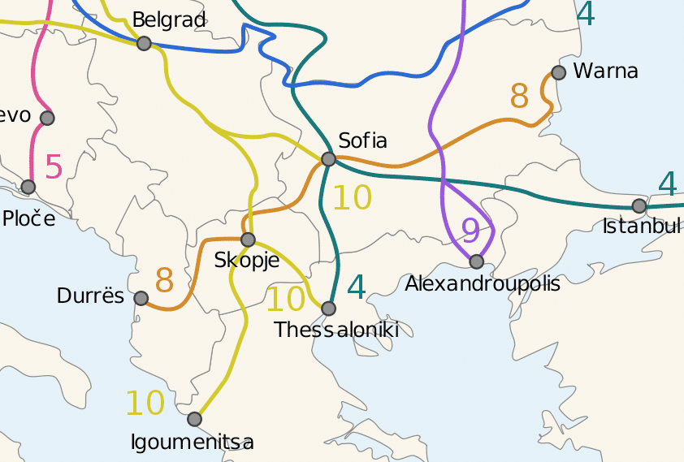

The border area is rich in minerals, e.g. chrome, coal, iron-nickel, cooper, chalk, quartz, sand and marble;

The cross-border region features diverse climatic conditions: from transitional –continental in the north to transitional –Mediterranean in the south and central parts. However, in the most mountain areas of these regions winters are cold and wet while summers are hot and dry. The temperatures in mountain areas along the border range from (minimum and maximum) -16 to +36 degrees. The average yearly precipitation on the Republic of Albanian side (+1,400 mm) is higher than on the side of the border of the former Yugoslav Republic of Macedonia (+600 mm).

Political Aspects

The former Yugoslav Republic of Macedonia had been identified as a potential candidate for EU membership in 2003. The country had applied for EU membership in March 2004 and was granted candidate status in 2005.

Similarly to the former Yugoslav Republic of Macedonia, Republic of Albania was identified as a potential candidate for EU membership in 2003. In 2009 Republic of Albania submitted its formal application for EU membership. In 2010 the Commission assessed that before accession negotiations could be formally opened, Republic of Albania still had to achieve a necessary degree of compliance with the membership criteria and in particular to meet the 12 key priorities identified in the Opinion. Later in 2012, the Commission recommended that Republic of Albania be granted EU candidate status, subject to completion of key measures in the areas of judicial and public administration reform and revision of the parliamentary rules of procedures.

For the former Yugoslav Republic of Macedonia the guiding policy reference framework is informed by the National Plan for the Adoption of Acquis, which informs national policies and government’s actions. The key strategic objectives of the Work Programme of the Government of the former Yugoslav Republic of Macedonia that relate to the period 2011–2015 include:

- Increase economic growth, employment and citizens’ standard of living, including quality of life;

- Integration of the former Yugoslav Republic of Macedonia into EU and NATO;

- Fight against corruption and crime and efficient law implementation by undertaking deep reforms in the judiciary and public administration;

- Maintenance of good inter–ethnic relations based on the principles of mutual tolerance and respect and implementation of the Ohrid Framework Agreement; and

- Support investment in education, science and information technology as elements of a knowledge–based society.

The former Yugoslav Republic of Macedonia’s 2009-2019 Strategy for Regional Development identifies inter-municipal and cross-border co-operation as one of the key pillars and objectives of balanced regional socio-economic development. Border regions, along with rural and mountainous areas are defined as specific development needs areas and thus become a priority for socio-economic intervention.

Republic of Albania’s National Strategy for Development and Integration 2014-2020 (NSDI) is considered as an overarching policy framework for the country in the context of EU integration. It defines four strategic policy pillars that lay down foundation for sectoral and place-based interventions:

- Strengthening democracy and the rule of law that addresses aspects like: election system, justice and home affairs, human rights and media, effective governance and foreign and defence policies;

- Creating conditions for competitive and sustainable economic development through efficient use of resources that covers: macroeconomic stability and sustainability, competitive market economy, efficient use of resources, integrated regional development and sustainable development;

- Fostering social inclusion, welfare and development of labour market that aim to promote: employment and social inclusion policies, social policy;

- Development of society based on knowledge, innovation and digital technology that includes interventions in the following areas: higher education, research and innovation, information and communication technology.

Republic of Albania’s Regional Development Cross-cutting Strategy distinguishes border areas as a cross-cutting policy planning subject and introduces cross-border issues into development policy planning at county level.

The 2012 Reports from the Commission to the European Parliament and the Council on the implementation of reforms within the framework of EU accession on the former Yugoslav Republic of Macedonia and Republic of Albania emphasise that the relationships between the two countries continue to improve and they provide sound grounds to exploit economic opportunities on both sides of the border.

Demography

Dynamics in the demography are distinct in the two countries. While the total population of Republic of Albania featured significant natural increase rates and doubled in the last 50 years, the population of the former Yugoslav Republic of Macedonia grew by approx. 29%.

At the end of 2012 the former Yugoslav Republic of Macedonia and Republic of Albania had total population of 2,061,044 and 2,815,749 respectively. The Programme Area includes 770,802 inhabitants in the former Yugoslav Republic of Macedonia (37.4% of its total population) and 656,873 inhabitants in Republic of Albania (23.3% of the country’s total population). More detailed breakdown of population by NUTS-3 and population density (persons/km²) level is provided below.

Programme Area | Number of Population | Population Density
Pelagonia | 232,959 | 49.4
Polog | 317,003 | 131.2
Southwest | 220,840 | 66.1
Total the former Yugoslav Republic of Macedonia Area | 770,802 | 73.6
Dibra | 137,811 | 37.1
Elbasan | 297,476 | 115.0
Korca | 221,586 | 23.3
Total Republic of Albanian Area | 656,873 | 69.2
Source: Statistical Office of the former Yugoslav Republic of Macedonia, INSTAT

Polog region with its capital in Tetovo and Elbasan with the main city of Elbasan are the biggest Programme Area statistical units in terms of population. The outstanding polycentric role of their main urban centres is reflected in population densities of the two regions.

Females make up 49.9% of the population in the three eligible regions on the territory of the former Yugoslav Republic of Macedonia, which mirrors population structure by sex in the whole country. In Republic of Albanian Programme Area females account for 9.5% of that population which is slightly below the median for the country (49.9%).

Population dynamics-wise, the former Yugoslav Republic of Macedonia Programme Area features positive natural increase in Polog and Southwest regions while all Republic of Albanian eligible areas and Pelagonia in the former Yugoslav Republic of Macedonia experience negative trends.

Yet, only natural increase rates paired with migration balance ultimately illustrate the actual demographic trends. Within the Programme Area only the former Yugoslav Republic of Macedonia's regions enjoy positive migration balance while all Republic of Albania's regions suffer from negative migration trends that contribute to depopulation of their areas. The negative migration balance in the respective Republic of Albanian regions is caused by the relocation of working contingent in 25-40 years cohort to seek for job opportunities in other regions. While outflow of males is more prevalent in Dibra and Elbasan, Korca features quicker migration of females to other areas.

None of the two countries experiences population ageing. On contrary, the median age in the former Yugoslav Republic of Macedonia remains the same for the past two years (38 years) and Republic of Albanian population becomes younger (median of 36 and 35 years respectively). Within the Programme Area the highest median age of population is in Pelagonia (40 years) and remains steady over recent years while the youngest region is Polog (35 years), with similar trends to those observed in Republic of Albania.

Young population (0-14 years cohort) accounts for 17.1% while elderly population (65+ years) make up 11.9% of the total the former Yugoslav Republic of Macedonia's population. In Republic of Albania the respective figures are: 20.3% and 11.6%, and there are no major variances across the country’s regions. On contrary, Polog and Pelagonia record the highest variance in regard to the share of their elderly population: 8.5% and 15.0% respectively.

Age dependency ratio is an issue for concern in Republic of Albania. Though the index slowly declines and reached 47 in 2012 while for the former Yugoslav Republic of Macedonia it is set at 41 the natural increase paired with the anticipated increase in life expectancy may negatively affect economy. In the Programme Area Pelagonia is the region most affected by aging population (age dependency ratio at 43) while in Republic of Albania it is Korca (approx. 50%).

Economic Cohesion

Both countries feature similar development level and are classified us upper-middle income economies by the World Bank, however their Gross National Income level merely exceeds the minimum demarcation line between this country category and lower-middle income economies.

Gross Domestic Product

Given the fact that analysis are carried out on NUTS-3 level and GDP per capita figures indicate outstanding position of the capital cities both in the former Yugoslav Republic of Macedonia and Republic of Albania elsewhere wealth is moderately distributed across each country with higher disparities observed in the former Yugoslav Republic of Macedonia when compared to Republic of Albania. GDP per capita in 2011 reached €3,631 in the former Yugoslav Republic of Macedonia and €3,214 in Republic of Albania. The table below illustrates disparities between the Programme Area regions and their country performance indicators.

Programme Area | GDP per Capita (EUR) | Index (country = 100)
Pelagonia | 3,702 | 102
Polog | 1,719 | 47
Southwest | 2,638 | 73
The former Yugoslav Republic of Macedonia | 3,631 | 100
Dibra | 1,999 | 62
Elbasan | 2,796 | 87
Korca | 2,526 | 79
Republic of Albania | 3,214 | 100
Source: Stare Statistical Office, INSTAT

Polog region is the most underdeveloped in the entire Programme Area and Dibra lags behind on the Republic of Albanian side. Indeed the region is the poorest in terms of economic performance in the entire Republic of Albania. Both regions border one another.

In 2012 the former Yugoslav Republic of Macedonia's GDP shrank by 0.2% while Republic of Albania recorded a meagre growth of 0.7%.

Gross Value Added by Sector

GVA illustrates the structure of the Programme Area economy and it is evident from statistical data that the former Yugoslav Republic of Macedonia’s economy formation is different to the structure of Republic of Albanian economy.

Republic of Albania relies on wholesale and retail markets that account for 31% of the country’s GVA but this sector is of a lesser importance in the Republic of Albanian Programme Area prefectures. These are predominantly agricultural regions with Diber and Korca’ agricultural output contributing 1/3 of the GVA in these regions. Agriculture in the former Yugoslav Republic of Macedonia’s Programme Area regions has significantly smaller contribution to the regional GVA with industry and other services being the primary sectors generating value added in those economies. Pelagonia’s mining and industry is the most important contributing factor to the wealth of this region. Indeed its industrial value added in absolute figures almost equals industrial GVA in all other Programme Area regions in the two countries.

Contribution to the GVA by different sectors is depicted in the figure below.
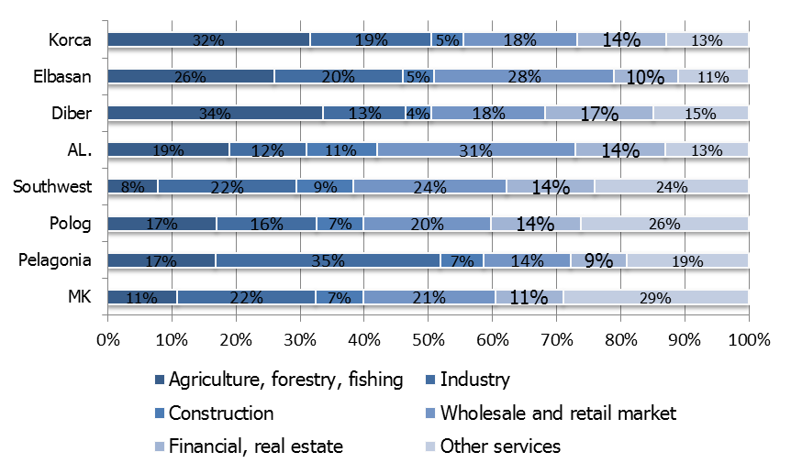
Source: own calculation based on State Statistical Office,
INSTAT

Foreign Trade

Share in foreign trade illustrates economic potential of each territory and it is evident that the Programme Area features low levels of economic activity and international competitiveness. Clearly, Pelagonia in the former Yugoslav Republic of Macedonia and Elbasan in Republic of Albania play the most important role in the internationalisation of the Programme Area economy (table below).

Programme Area | Share in Exports (%) | Share in Imports (%)
Pelagonia | 6.4 | 3.9
Polog | 2.7 | 2.9
Southwest | 1.9 | 1.8
The former Yugoslav Republic of Macedonia | 100 | 100
Dibra | 1.4 | 0.1
Elbasan | 9.9 | 7.1
Korca | 3.2 | 2.6
Republic of Albania | 100 | 100
Source: State Statistical Office (the former Yugoslav Republic of Macedonia), General Directory of Customs (Republic of Albania)

Mining and Energy

The border area between the both countries is rich in minerals and natural resources. While coal mining is the most important for the former Yugoslav Republic of Macedonia border area in Kicevo and Pelagonia basins, the Republic of Albanian border area exploits - in addition to coal - iron, copper and chromite. The belt between Bilisht and Librazhd has significant deposits of iron and nickel ore. Dibra and Elbasan prefectures are rich in chrome with Northern Bulquiza mine being of strategic importance. Coal is exploited in Korca, however coal deposits in this area only account for approx. 10% of all Republic of Albanian coals.

The former Yugoslav Republic of Macedonia and Republic of Albania coal deposits are lignites with relatively low caloric value and high content of damp and ash from geological Pliocene and Miocene age.

Other minerals include: titanomagnetites, talc, granite, marble, limestones, dolomites and other carbonatic decorative stones.

In the former Yugoslav Republic of Macedonia Polog and Southwest regions are home to 9 hydroelectric power plants and there is a solar power plant in Pelagonia. Republic of Albanian border area features 41 hydro power plants, chiefly on the Drin and Devoll Rivers. The installed total electricity production capacity illustrates the former Yugoslav Republic of Macedonia’s advantage though it is Republic of Albania that produces greener electricity thanks to its hydroelectric power plants.

In the Programme Area the former Yugoslav Republic of Macedonia’s regions produce 60% of the former Yugoslav Republic of Macedonia’s electricity while Republic of Albanian regions account for 47% of the country’s power plants capacity.

Programme Area | Capacity (MW)
Pelagonia | 685
Polog | 190
Southwest | 258
The former Yugoslav Republic of Macedonia | 1,889
Dibra | 39.7
Elbasan | 18.9
Korca | 32.0
Republic of Albania | 195.8
Source: Statistical Office (the former Yugoslav Republic of Macedonia), Electricity Regulatory Entity (Republic of Albania), 2012

Entrepreneurship

The Programme Area features economic activities by small and medium sized enterprises. However their importance in the regional economy is lower than in other regions of the two countries. Only 32% of all of the former Yugoslav Republic of Macedonia and 17% of Republic of Albania SMEs are located in the Programme Area and these values are considered very low given the size of population in the border regions.

The already highlighted regional disparities also manifest in the disproportion of the SME intensity in each eligible region. Of all Programme Area SMEs small and medium businesses are most prevalent in Pelogonia in the former Yugoslav Republic of Macedonia and Korca in Republic of Albania. Other districts feature lower numbers of SMEs, as depicted in the chart below.

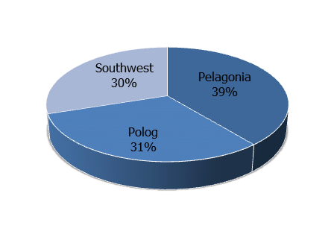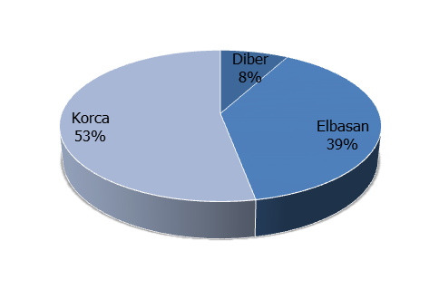
Source: own calculation based on State Statistical Office , INSTAT

While mining and associated industries in the former Yugoslav Republic of Macedonia are capable to attract small businesses and create value chain opportunities the Republic of Albanian heavy industries produce little spill-over effect and very few economic opportunities for small businesses.

In border areas businesses normally exploit international trade opportunities but trade between the both countries and third parties is constrained by administrative barriers, chiefly in Republic of Albania. While enjoying high comparative cost advantage to import and export goods Republic of Albanian SMEs operate in one of the most unfavourable administrative frameworks in Europe for business internationalisation. The key aspects of that problem are outlined in the table below (based on SBA Fact Sheets).

Factor | Republic of Macedonia | Republic of Albania
Cost required to import (USD) | 1,380 | 710
Time required to import (days) | 11 | 18
Number of documents required to import | 6 | 9
Cost required to export (USD) | 1,376 | 725
Time required to export (days) | 12 | 19
Number of documents required to export | 6 | 7
Source: SBA Fact Sheets, DG Enterprise

Administrative burden and poor competitiveness result in significant foreign trade deficit between the two countries in disfavour of Republic of Albania.

Employment

Based on LFS findings, at the turn of 2012 and 2013 the former Yugoslav Republic of Macedonia and Republic of Albania had 56.5% 63.2% of economically active working age population (15-64 years cohort) respectively, with significant disparities across the both countries. In the former Yugoslav Republic of Macedonia the highest percentage (60.9%) was recorder in Southeast region and the lowest - in Polog region (44.3%). Though regional figures are not available for Republic of Albania it is estimated that the Tirana region records higher activity rates than the rest of the country and that the Republic of Albanian Border features activity rates significantly below the median for the country.

Employment rate at 44% in the former Yugoslav Republic of Macedonia is lower than for Republic of Albania (50.1%). In the CBC Border Area Pelagonia features the highest rate (46.9%) while Polog and Southwest - 29.3% and 32.4% respectively. Republic of Albanian CBC regions feature higher employment rates, all exceeding the median for the country: Diber 55%, Elbasan: 55.7% and Korca - 53.8%. These high employment rates result from subsistence and low-scale agricultural production that provide a form of social security for the bulk of the rural population and work as a buffer against high rates of registered unemployment.

Employment Rate | The former Yugoslav Republic of Macedonia | Republic of Albania
Males | 52.4 | 56.6
Females | 35.3 | 43.7
Source: LFS by State Statistical Office, INSTAT

Employment levels by gender also depict significant disparities between the two countries. For Republic of Albania both males and females are more active in the labour market and more frequently find income making opportunities than their counterparts in the former Yugoslav Republic of Macedonia. These disproportions however result chiefly from high structural share of employment in agricultural sector where 40% of economically active males and 60% of females work.

Sector-wise, the highest share in employment creation in Republic of Albania has agriculture (including fishery and forestry), which employs approx. 48.7% of the economically active population while in the former Yugoslav Republic of Macedonia this sector accounts for 17.3% of all employed. Manufacturing, industry and construction is the largest employer in the former Yugoslav Republic of Macedonia and accounts for 29.9% of all employed. In Republic of Albania the sector contributes merely 16% of job opportunities.

There are no specific data on employment by sector on regional level but it is estimated that Service sector is the main contributor in the former Yugoslav Republic of Macedonia and Agriculture in Republic of Albania.

Tourism

Nature, cultural and historical heritage are the key foundations of tourism development in the Border Area. Tourism potential is significant in the Border Area but the former Yugoslav Republic of Macedonia has developed tourism industry and tapped into value chain opportunities on much larger scale than Republic of Albania. This is illustrated by the number of overnight stays in accommodation establishments: while the former Yugoslav Republic of Macedonia registered in 2012 more than 2.1 million Republic of Albania recorded merely 0.8 million of overnight tourist stays. Domestic tourism in Republic of Albania accounts for 55.6% while in the former Yugoslav Republic of Macedonia - for 62.2% of the entire tourism industry. With more than 26.8 thousand rooms in accommodation establishments the country features higher accommodation capacity than Republic of Albania (with only 18.9 thousand rooms).

There are however structural and regional differences between the two countries: while Republic of Albania’s priority tourism destinations are on the coast of the Adriatic and Ionian Seas, the former Yugoslav Republic of Macedonia’s tourism infrastructure concentrates in the Southwest region. Indeed, tourism traffic in Southwest is the largest of all regions in the country and accounts for 45.1% of the total number of tourists in the country with areas around the Ohrid and Prespa Lakes being the main focal points. Tourism traffic in Republic of Albania’s Programme Area is relatively insignificant when compared to the former Yugoslav Republic of Macedonia's Cross Border Area though due to the lack of specific regional data on the subject no further conclusion can be derived.

Rural Economy

In the Programme Area land elevation creates favourable conditions for forestry and it is Southwest and Pelagonia in the former Yugoslav Republic of Macedonia and all Republic of Albania’s CBC regions where forests’ coverage is above the countries’ median. Indeed, Republic of Albania features one of the lowest shares of arable land in all agricultural land across Europe. Land elevation negatively affects rural economy of the Border Area communities and reduces basic economic and income opportunities that derive from land utilisation.

Yet, rural economy and agriculture is an important sector of economy in the two countries though it is Republic of Albania that relies on food production on much large scale than the former Yugoslav Republic of Macedonia. The table below provides essential facts on rural economic potential in the context of agricultural land (figures in ‘000 ha unless quoted otherwise).

Country/Region | Total  Agricultural land | Arable land and  gardens | Arable land as % of Agricultural land | Average Farm Size  (ha)
The former Yugoslav Republic of Macedonia | 1,268 | 510 | 40 | 1.60
Pelagonia | 263 | 112 | 43 | 2.90
Polog | 169 | 43 | 25 | 4.10
Southwest | 136 | 50 | 37 | 3.00
Republic of Albania | 2,875 | 696 | 24 | 1.20
Dibra | 249 | 41 | 16 | 0.72
Elbasan | 327 | 73 | 22 | 1.26
Korca | 371 | 91 | 25 | 1.27
Source: INSTAT, Ministry of Agriculture, Forestry and Water Economy (the former Yugoslav Republic of Macedonia) and: own calculations based on World Bank data for farm size in the former Yugoslav Republic of Macedonia, 2012

In the former Yugoslav Republic of Macedonia arable land accounts for 40% of all agricultural land while in Republic of Albania this ratio is 24%. On average in both countries’ Programme Area the arable area share in the total size of agricultural land is below the country’s median depicting unfavourable conditions for rural economy but it is the former Yugoslav Republic of Macedonia where agricultural production stands more favourable natural conditions for crops and livestock production.

Both countries have fragmented rural economy. In Republic of Albania the average size of farm is 1.2 ha and only Dibra region is below the country’s median. In the former Yugoslav Republic of Macedonia the average farm size is 1.6 ha but the Programme Area features significantly larger agricultural holdings than elsewhere in the country.

The main crops in the Programme Area are outlined in the table below. Crops are sequenced according to the total production output per country and region.

Country/Region | Main Agricultural Production
The former Yugoslav Republic of Macedonia | Wheat, vegetables, potatoes, corn, clover
Pelagonia | Wheat, vegetables, potatoes, fruits, lucerne, tobacco,
Polog | Corn, potatoes, vegetables, lucerne, clover
Southwest | Potatoes, wheat, corn, lucerne, vegetables, fruits
Republic of Albania | Wheat, corn, vegetables, beans, potatoes, oats
Dibra | Corn, wheat, vegetables
Elbasan | Wheat, corn, vegetables, oats, beans, potatoes, livestock, fruits and grapes
Korca | Wheat, corn, vegetables, beans, barley
Source: own elaboration based on INSTAT, Ministry of Agriculture, Food and Consumer Protection (Republic of Albania) and State Statistical Office (the former Yugoslav Republic of Macedonia), 2012

While Republic of Albanian CBC Area specialises in cereals, vegetables, beans and oats production, the former Yugoslav Republic of Macedonia’s rural economy is more diversified and the regions clearly specialise in varieties of crops. The Southwest and Elbasan regions are examples where yields are high and production is diversified while Korca and Polog hit lowest yields in agricultural production.

Rural economy in the Programme Area is negatively affected by soil erosion. Land elevation, especially relief in which mountains, hills and valleys alternate paired with torrent character of precipitation contribute to accelerated losses of soils. There are no specific regional data on soil erosion but on national level Republic of Albania is estimated to lose more than 16 t/ha per year while the former Yugoslav Republic of Macedonia this figure is estimated to exceed 18 t/ha.

Transport Infrastructure

The key data on infrastructure and transport are depicted in the table below.

Indicator | The former Yugoslav Republic of Macedonia | Republic of Albania
Railroads (km) | 696 | 399
Roads total (km) | 13,983 | 18,000
Locomotives | 52 | 53
Goods in rail transport (‘000 t-km) | 478,925 | 8,333
Passenger cars | 313,084 | 300,974
Goods vehicles | 27,917 | 71,278
Buses | 2,636 | 6,698
Source: State Statistical Office (the former Yugoslav Republic of Macedonia), INSTAT, Ministry of Public Works and Transport (Republic of Republic of Albania), 2012

There are no data that illustrate regional breakdown of transport infrastructure but for the two countries the transport route of the common interest is West-East Corridor VIII and for the Border Area it is a section Elbasan-Cafasan-Skopje. Recently completed highway Tirana-Elbasan is an important upgrade to this international route, which improves road transport safety conditions and accessibility.

Road transport appears as the most important mode of transport as there is no railroad connecting the two countries - the line Skopje-Kicevo does not extend further towards Ohrid and to the border.

Social cohesion

This section outlines key features of the Programme Area’s capacity to ensure the well-being of its people while minimising disparities and avoiding marginalisation.

Unemployment

Unemployment rates according to LFS methodology represent significant disparities across the border between the two countries. Clearly, joblessness is an issue of very high concern in the former Yugoslav Republic of Macedonia while for Republic of Albania much of the labour force is absorbed by fragmented rural economy.

Programme Area | Unemployment (%)
Pelagonia | 25.3
Polog | 34.2
Southwest | 42.3
The former Yugoslav Republic of Macedonia | 31.0
Dibra | 8.7
Elbasan | 6.0
Korca | 10.4
Republic of Albania | 13.4
Source: State Statistical Office, INSTAT, LFS 2012

Earnings

Average net paid to employees in the former Yugoslav Republic of Macedonia amounts to €335 and in Republic of Albania - €356 and the people in Republic of Albania earn 7% more than those living in the former Yugoslav Republic of Macedonia. Net salaries deviate across the regions in both countries but the eligible Programme Area does not feature significant disparities in the level of net earnings.

Programme Area | Net paid, Country=100
Pelagonia | 91.7
Polog | 95.6
Southwest | 90.8
The former Yugoslav Republic of Macedonia | 100
Dibra | 97.0
Elbasan | 95.7
Korca | 100.3
Republic of Albania | 100
Source: State Statistical Office, own calculation based on ISTAT data

Information Society

The Programme Area features high disparities in access to and use of information technology, which is one of the main driving forces of contemporary economic development. The imbalances relate to disproportions between the two countries and across eligible Republic of Albanian regions.

Programme Area | Use of Computers | Use of Internet
Pelagonia | 61.0 | 55.0
Polog | 64.0 | 64.0
Southwest | 64.0 | 57.0
The former Yugoslav Republic of Macedonia | 64.0 | 58.0
Dibra | 15.5 | 6.5
Elbasan | 16.8 | 8.3
Korca | 14.5 | 11.0
Republic of Albania | 20.2 | 14.1
Source: State Statistical Office, INSTAT,LSMS 2012

The data above illustrate a digital divide between the former Yugoslav Republic of Macedonia and Republic of Albania, and Republic of Albanian households and businesses are obviously exposed to digital exclusion. The occurrence is a critical concern as it does not result from people’s disability or age. For the former Yugoslav Republic of Macedonia the benchmark rates are high but lower than across EU Member States by approx. 30% on average.
Literacy

In both countries literacy rate is considered high - 96% for the former Yugoslav Republic of Macedonia and 97% for Republic of Albania. There are no major regional deviations from the national median or disparities across the regions comprising the Programme Area.

Education and Schooling

Schooling and education are central structures and instruments to develop and shape human capital that has a fundamental role in building up a sustainable knowledge-based economy, competitiveness, social cohesion and sustainability.

While access to primary education is relatively balanced and schools are not overcrowded, upper secondary education appears to be under strain, especially in Republic of Albania with Dibra region being particularly exposed to insufficient schooling infrastructure. Here the average number of pupils per teacher is significantly higher than the median for the country (see table below).

Programme Area | No of pupils per teacher (primary) | Number of pupils per teacher  (secondary) | Graduated students per 1,000  population
Pelagonia | 11 | 14 | 118
Polog | 12 | 13 | 71
Southwest | 10 | 13 | 92
The former Yugoslav Republic of Macedonia | 12 | 13 | 103
Dibra | 15 | 21 | 39
Elbasan | 14 | 16 | 63
Korca | 13 | 15 | 77
Republic of Albania | 16 | 16 | 94
Source: own calculation based on raw data from State Statistical Office and INSTAT, 2011

The 21st century features brain drain, which is a widespread occurrence as the role of cities and urban centres increases, widening the urban-rural divide. This phenomenon seriously affects the Programme Area except for Pelagonia region. Elsewhere the problem is prevalent (more in Republic of Albania) with negative peak in Dibra where the share of people with university education is the lowest in the entire CBC Programme territory.

Water Supply and Waste Management

In the Programme Area approx. 97% of the former Yugoslav Republic of Macedonia's households are connected to individual or public water supply systems and 95% - to waste water facilities. Respectively, in Republic of Albania these figures are: 95% and 87%.

There are no statistics on the volume of waste water treatment but it is estimated that a meagre of up to 10% of liquid waste is treated. Untreated sewerage - in addition to uncontrolled use of fertilisers in agriculture is the key reason for accelerated eutrophication of the abundance of aquatic ecosystems in the Programme Area (lakes and rivers).

Solid waste-wise, 70% of the generated waste in the former Yugoslav Republic of Macedonia is collected but for Republic of Albania this share is estimated at significantly lower levels.

The table below outlines statistics on the collected solid waste in the Programme Area.

Programme Area | Tones (‘000) | Share (%), Country=100
Pelagonia | 72 | 13.0
Polog | 59 | 10.6
Southwest | 49 | 8.8
The former Yugoslav Republic of Macedonia | 555 | 100
Dibra | 33.1 | 2.9
Elbasan | 81.1 | 7.1
Korca | 62.1 | 5.4
Republic of Albania | 1,137 | 100
Source: State Statistical Office (the former Yugoslav Republic of Macedonia), Ministry of Environment (Republic of Albania), 2012

In the former Yugoslav Republic of Macedonia solid waste landfills capacity is reasonably distributed across regions and satisfactorily correspond to the volume of waste generated however there is no corresponding data available for Republic of Albania.

Solid waste management is a concern matter due to low ratio of waste generated and collected. In addition to that waste disposal segregation is almost non-existent which increases the cost of waste management and affects the environment.

Healthcare Infrastructure

Healthcare infrastructure features significant disparities across the border. On average, the former Yugoslav Republic of Macedonia offers better availability of specialised medical treatment and Pelagonia has the most competitive healthcare infrastructure in the whole Programme Area. Though the CBC territory on the Republic of Albanian side can offer more beds in hospitals than the median for the whole nation the country entered into strategic agreement with the former Yugoslav Republic of Macedonia and Republic of Albanian citizens with chronic diseases can use hospitals and clinic in the former Yugoslav Republic of Macedonia for some specialised treatment. This is due to limited availability of modern equipment or arduous physical accessibility of healthcare infrastructure on the Republic of Albanian side, chiefly in more remote areas.

Programme Area | No of hospitals | No of hospital beds | No of hospital beds per 1,000 inhabitants
Pelagonia | 3 | 1,419 | 6,1
Polog | 7 | 646 | 2
Southwest | 5 | 815 | 2
The former Yugoslav Republic of Macedonia | 73 | 9,076 | 4,4
Dibra | 3 | 508 | 3,7
Elbasan | 6 | 1,020 | 3,4
Korca | 4 | 752 | 3,4
Republic of Albania | 44 | 8,410 | 3
Source: Ministry of Health (The former Yugoslav Republic of Macedonia, Republic of Albania)

SWOT Analysis

This SWOT analysis follows the logic of thematic prioritisation of IPA II assistance and outlines strengths, weaknesses, opportunities and threats considering their strategic (need or opportunity quality) or effect character. This SWOT covers only those themes that were considered for the inclusion into strategic intervention and augments problem tree analysis depicted in Section 2.2 of the Programme document.

SWOT is compiled based on the individual questionnaires from Programme stakeholders, feedback from the existing Regional Development Strategies of NUTS-3 regions in the border area and expert conclusions of the region’s socio-economic profile.

The analysis below follows the sequence of importance of Thematic Priorities selected for IPA II CBCB 2014-2020 Programme.

Tourism and cultural and natural heritage (TP4)

Uneven level of development of tourist infrastructure in the CBC region makes, at present, the overall region unattractive for an inclusive tourist offer, especially on the Republic of Albanian side. Thus alternative forms of tourism could be used as a basis for building an image of the Programme Ares as an attractive tourism destination.

Rich cultural heritage is not well maintained and presented. Thus initiatives based on increasing co-operation between people and institutions from the CBC region should be intensified in the future.

Strengths | Weaknesses
(Effect) Rich tourist offer based on exploitation of natural resources, cultural heritage, religious monuments, thermal waters, sport and leisure | (Strategic weakness) No balanced level of tourism infrastructure (accommodation, sports, terrains) and absence of strategy for sustainable tourist offer of the CBC region
(Strategic strength) Experience in hosting domestic and international guests | (Effect) Lack of international recognition of the whole CBC region as attractive tourist destination
(Strategic strength) Part of the CBC territory increases its recognition as important tourism domestic tourism destination | (Effect) Inappropriate maintenance of historical and cultural monuments
Opportunities | Threats
(Effect) Integral tourist offer based on culture, sport, leisure, adventure, spa tourism | (Effect) Absence of integrated tourism development strategy and dedicated measures for the CBC region
(Strategic opportunity) More effective and integrated exchange of experiences between two countries and operators | (Strategic threat)unbalanced investments in tourism infrastructure
(Strategic opportunity) Joint plan for mapping and preservation and maintenance of cultural and historical monuments | (Effect)Rather poor image of the CBC region
(Strategic opportunity) Joint cultural events

Competitiveness, business, trade and investment (TP7)

SMEs, entrepreneurship and rural economy appear as one of the main driving forces of economic development in the Programme Area. They are sensitive to policy and market changes, mostly due to their limited competitiveness and market orientation. Thus, light industries, sustainable agriculture and food processing sectors are considered as a potential for more sustainable economic growth of the CBC region as a whole.

Strengths | Weaknesses
(Strategic strength)Existing base of SMEs in the overall region with diversified activities | (Strategic weakness) SMEs are of micro character and extremely susceptible to political, fiscal or market changes
(Strategic strength) Diversified agriculture production and rural economy in the whole region | (Strategic weakness) Lack of specialization, added value, research and thorough market orientation
(Effect) Stable and competitive medium sized businesses, especially in the regions of Polog, Elbasan and Pelagonija | (Effect) Limited competitiveness on regional and national level of products, low levels of GVA
 | (Strategic weakness) Agriculture characterized by large fragmentation, limited productivity and lack of market orientation
 | (Strategic weakness)Underutilized natural resources available for competitive agriculture and food production practices
 | (Strategic threat)Limited offer of semi-finished products with consistent quantity
Opportunities | Threats
(Effect) Economic development based on sustainable utilization of available natural resources and value chains | (Effect) Large discrepancies in level of development and economic activities between different regions in CBC area
(Strategic opportunity) Specialization of SMEs and their strengthening though adding value to their products | (Effect) Insufficient export activities
(Strategic opportunity) Identification of products that could be internationally branded | (Effect) Micro enterprises, not resistant to market changes
(Strategic opportunity) Organic or at least sustainable organic agriculture production and food processing | (Strategic threat) Extensive agriculture production with limited market attractiveness
(Strategic opportunity)More developed cooperation and trade between companies in the CBC region | (Strategic threat) High soil erosion due to land elevation
(Strategic opportunity) Development of business infrastructure and business networking (incubators, business support centers, associations, etc.)

Environment, climate change adaptation and mitigation, risk prevention and management (TP2)

Despite intensive mining on limited territory the CBC region is perceived as “green area” suitable for economic development based on sustainable exploitation of its natural resources due to abundant forests, rivers and lakes. However, the region does not feature any major environmental monitoring or risk prevention system. Furthermore, absence of the minimum required environmental infrastructure (waste water treatment, solid waste disposal etc.) could lead to further uncontrolled pollution in the region and decreasing attractiveness business activities based on sustainable natural resources utilisation.

Strengths | Weaknesses
(Strategic strength) Presence of diversified natural resources (water, forests, flora and fauna, climate) | (Strategic weakness) Lack of plans for environment protection, monitoring and risk prevention systems for any kind of pollution in the region and prevention of soil erosion
(Effect) “clean area” without major industrial pollution | (Strategic weakness) Lack of control of exploitation of natural resources (mining, forests)
(Strategic strength) Presence of different climate zones (mountainous, continental and Mediterranean) enables more specialized agriculture production and alternative tourism development | (Effect) Low awareness of population about protecting environment
Opportunities | Threats
(Effect) Development of joint strategy for CBC regional environmental protection, monitoring and early risk recognition and prevention | (Effect) Micro regions with a threat for pollution that could jeopardize development of other economic/tourism activities
(Strategic opportunity) Develop joint programs for waste treatment | (Strategic threat) Lack of incentives and investments in environmental protection and/or more friendly technologies
(Strategic opportunity) Design and development of projects, feasibility studies for protection on international waters and underground waters | (Strategic threat) International waters with high risk of pollution

As of end of 2012; source: INSTAT and State Statistical Office
Related to employment (TP1) which will be considered as a cross-cutting issue.
Ranking was made through individual SWOT questionnaire circulated to major stakeholders.
Interim Evaluation of Cross-Border Programmes between Candidate/Potential Candidate Country (Intra-Western Balkan Borders) under the Cross-Border Cooperation Component of IPA; Report II – Performance of the assistance
These are of indicative nature based on the assumption that up to three CfP’s will be organised throughout the entire lifespan of the Programme. The modality may change during the programme implementation.
These are of indicative nature based on the assumption that up to three CfP’s will be organised throughout the entire lifespan of the Programme. The modality may change during the programme implementation.
These are of indicative nature based on the assumption that up to three CfP’s will be organised throughout the entire lifespan of the Programme. The modality may change during the programme implementation.
Requires a regular and simple survey using a standard questionnaire with closed types of questions.
Please note that in the financial perspective 2014-2020 possible tailored/strategic Calls for Proposals are envisaged with clear focus and/or certain requirements regarding potential beneficiaries. Also, Calls for Proposals might use the rotating principle for the selection of thematic priorities (TP) and their specific objectives and in that respect the number of proposals might not necessarily be increased. For these reasons, the potential expected increase in the number of applications received could be calculated for each consecutive call individually and will be affected by a factor that could be calculated based on: 1) Total financial envelope available, 2) Thematic priorities, specific objectives and results included in the Call for Proposals, 3) Minimum and maximum amounts of grants allowed, 4) Number of applications and grants allowed per applicant/co-applicant/affiliated entity and 5) Any other special provisions influencing various eligibility criteria applicable for a specific call for proposals.
Corridors defined according to the conclusions of the Crete Conference (1994) and Helsinki Conference (1997) on Pan-European multimodal corridors and MoU signed by Western Balkan countries (2004)
Source: the World Bank
Source: State Statistical Office; own calculation based on raw INSTAT data
Source: op. cit.
Source: ibidem
Source: Joint Research Centre, European Commission
The Operating Structures concluded in July 2013 that the list of TPs shall be narrowed before entering broader consultative programming phase due to limited financial resource of the Programme. Subsequently, TPs were ranked according to their importance and included for 2014-2020 intervention.

