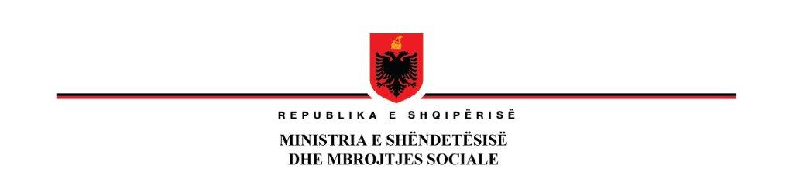

**02nd of May 2023**

**Njoftim Fituesi**

|  |  |
| --- | --- |
| Emri i Projektit: | **Përmirësimi i Sistemit të Shëndetësisë (HSIP)- Financim Shtesë** |
| Financimi: | **Hua nga IBRD No. Loan No 93060 AL** |
| Referenca e prokurimit: | **AL-MH-330907-CS-CQS** |
| Përshkrimi i kontratës: | **Shërbim Konsulence për supervizimin e Spitalit Angiologji/Kardiokirurgji në QSUT** |
| Emri i kontraktorit: | **TAULANT sh.p.k** |
| Adresa e kontraktorit: | **Rruga Gjik Kuçali Ndërtesa 23/2, Hyrja , apartamenti 1 kati 1, Tiranë Shqipëri** |
| Tavani i Kontratës: | **5,190,000 lekë me TVSH** |
| Periudha e zbatimit të kontratës: | **27 prill 2023 deri 31 Dhjetor 2024** |
| Data e nënshkrimit të kontratës | **27 prill 2023** |

**ZËVENDËSMINISTËR**

**Entela RAMOSAÇAJ**

___________________________________________________________________________Adresa: Rruga “Kavajes”, Tirana, Albania, Tel: +355 4 23646 22, [www.shendetesia.gov.al](http://www.shendetesia.gov.al)





**02nd of May 2023**

**Notification for Contract Award**

|  |  |
| --- | --- |
| Project name: | **Health System Improvement Project (HSIP)** |
| Source of Funding: | **IBRD Loan No. 93060 AL** |
| Procurement reference: | **AL-MH-330907-CS-CQS** |
| Brief Description of Contract: | **Consulting services for the supervision of Angiology/ Cardio surgery Hospital in QSUT** |
| Consultant's name: | **TAULANT sh.p.k** |
| Consultant's address: | **Rruga Gjik Kuçali Ndërtesa 23/2, Hyrja , apartamenti 1 kati 1, Tiranë Shqipëri** |
| Contract Ceiling: | **5,190,000 Albanian lekë including VAT** |
| Contract Implementation Period: | **27 April 2023 until 31 December 2024** |
| Contract Signature Date: | **27 April 2023** |

**DEPUTYMINISTER**

**Entela RAMOSAÇAJ**

___________________________________________________________________________Adresa: Rruga “Kavajes”, Tirana, Albania, Tel: +355 4 23646 22, [www.shendetesia.gov.al](http://www.shendetesia.gov.al)