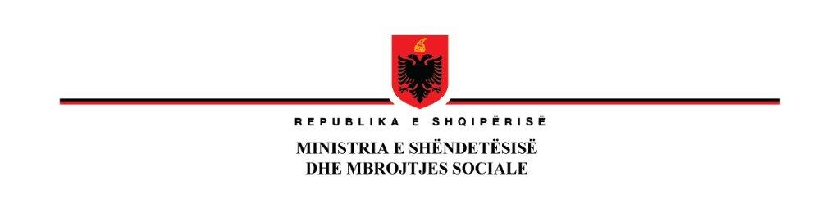

**ADDENDUM NO.2 TO BIDDING DOCUMENTS**

**Procurement of: Supply with Biplane Angiography System**

**RFB No: AL-MH-430620-GO-RFB**

**Issued on: 31 July 2024**

|  |  |  |
| --- | --- | --- |
| **No** | **Actual requirement** | **To be modified into** |
| 1 | **ITB 18.1**  The bid shall be valid until 30 October 2024 | **ITB 18.1 shall rad as follows:**  The bid shall be valid until 10th of November 2024 |
| 2 | **ITB 19.1**  A Bid Security shall be required. A Bid Security shall be required.  The Bid security shall be accepted only in the form of Banks Guarantee and shall be valid until 27 November 2024. The amount of Bid security is 21,000 Euro | **ITB 19.1 shall read as follows:**  A Bid Security shall be required. A Bid Security shall be required.  The Bid security shall be accepted only in the form of Banks Guarantee and shall be valid until 8th of December 2024. The amount of Bid security is 21,000 Euro |
| 3 | **ITB 22.1**  For Bid submission purposes only, the Purchaser‘s address is:  Manager Address: Ministry of Health and Social Protection, Rr. Kavajës- Tirana Albania  City: Tirana ZIP Code: 1000  Country: Albania  The deadline for Bid submission is:  Date: **01 August 2024**  Time: 11:00 AM local time  Bidders shall not have the option of submitting their Bids electronically | **ITB 22.1 shall read as follows**  For Bid submission purposes only, the Purchaser‘s address is:  Manager Address: Ministry of Health and Social Protection, Rr. Kavajës- Tirana Albania  City: Tirana ZIP Code: 1000  Country: Albania  The deadline for Bid submission is:  Date: **12 August 2024**  Time: 11:00 AM local time  Bidders shall not have the option of submitting their Bids electronically |
| 4 | **ITB 25.1**  The Bid opening shall take place at:  Ministry of Health and Social Protection  Manager Address: Ministry of Health and Social Protection, Rr. Kavajës- Tirana Albania  City: Tirana  ZIP Code: 1000  Country: Albania  Date: **01 August 2024**  Time: 11:15 AM local time | **ITB 25.1 shall read as follows:**  The Bid opening shall take place at:  Ministry of Health and Social Protection  Manager Address: Ministry of Health and Social Protection, Rr. Kavajës- Tirana Albania  City: Tirana  ZIP Code: 1000  Country: Albania  Date: **12 August 2024**  Time: 11:15 AM local time |

All other parts of the Bidding documents remain unchanged.