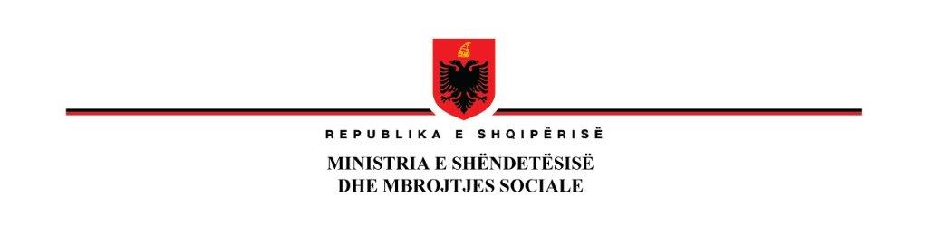

**Addendum No.2 to Bidding documents for Supply and Installation of Equipment, local networks for Hospitals**

**IFB No: AL-MH-330917-GO-RFB**

**Issued on 31.07.2024**

|  |  |
| --- | --- |
| **Existing Clause** | **Amended Clause** |
| **ITB 18.1** The Bid shall be valid until: 30th of October 2024 | **ITB 18.1 shall read as follows:**  The Bid shall be valid until: 10 November 2024 |
| **ITB 19.1**  A Bid Security is required. Bids need to be secured by a Bid Security in the form of a Bank Guarantee. The amount of Bid Security required is: 21,000 Euro. The Bid security must be valid until 24th of November 2024. Only Bank guarantee is accepted and in case that the Bidder provides other types of Bid security, the Bid shall be rejected as non responsive. | **ITB 19.1 shall read as follows:**  A Bid Security is required. Bids need to be secured by a Bid Security in the form of a Bank Guarantee. The amount of Bid Security required is: 21,000 Euro. The Bid security must be valid until 08th of December 2024. Only Bank guarantee is accepted and in case that the Bidder provides other types of Bid security, the Bid shall be rejected as non-responsive. |
| **ITB 22.1**  The address for bid submission is:  Ministry of Health and Social Protection Albania  Ina ttention to Entela Ramosaçaj  Address: Rruga e Kavajës  City: Tirana  ZIP Code: 1001  Country: Albania  Deadline for bid submission is:  Date: 01th of August 2024  Time: local time 11:00 | **ITB 22.1 shall read as follows:**  The address for bid submission is:  Ministry of Health and Social Protection Albania  Ina ttention to Entela Ramosaçaj  Address: Rruga e Kavajës  City: Tirana  ZIP Code: 1001  Country: Albania  Deadline for bid submission is:  Date: 12th of August 2024  Time: local time 14:00 |
| **ITB 25.1**  The Bid opening shall take place at:  Time, date, and place for bid opening are:  Date 01th of August 2024  Local time: local time 11:00  Ministry of Health and Social Protection Albania  Address: Rruga e Kavajës  City: Tirana  ZIP Code: 1001  Country: Albania | **ITB 25.1 shall read as follows:**  The Bid opening shall take place at:  Time, date, and place for bid opening are:  Date 12th of August 2024  Local time: local time 14:00  Ministry of Health and Social Protection Albania  Address: Rruga e Kavajës  City: Tirana  ZIP Code: 1001  Country: Albania |