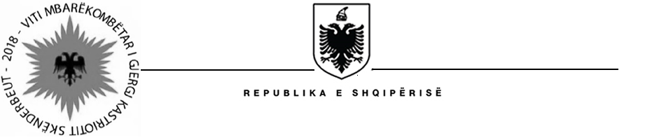
MINISTRIA E SHËNDETËSISË DHE MBROJTJES SOCIALE
SOCIAL ASSISTANCE MODERNIZATION PROJECT (SAMP)

January 25, 2018

CANCELLATION OF A CONSULTANT SERVICE PROCEDURE

Procurement Reference: | SAMP/CS/IC/16-2016
Description of the assignment : | “Local Individual IT expert to assist MSWY in the implementation and effective use of the NE and DA MIS systems”
Consultant’s Name who submitted their interest : | - Mr. Mandi Cukalla
Date of procedure cancelation | January 25, 2018
Reason for cancellation | - Due to the changes in the institutional set up of the implementing agency (current MHSP) after the national elections of June 2017 and the progress made in the implementation of the undertaken reforms, the ToRs will be revised and updated to better fit with.
Further actions: | - Selection procedure will be re-started based on the new revised ToR-s and the consultants will be notified through a REOI.

