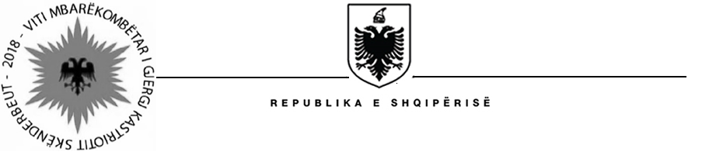

MINISTRY OF HEALTH AND SOCIAL PROTECTION
SOCIAL ASSISTANCE MODERNIZATION PROJECT (SAMP)

Contract Award

Project Name: Social Assistance Modernization Project
Country: Albania
IBRD Loan Number: 8141-AL
Report Period: October 30, 2018
Procurement Reference: | Ref. no. SAMP/CS/CQ/05-2016
Description of the assignment: | “Design of improved error, fraud, and framework and implementation procedures for disability assistance. Training of social inspectors on improved inspection, sanction and remedy/recovery policy”
Consultant’s Name: | Association for Integration of Informal Areas (SHIZI)
Consultant’s Address : | Rr. “Bajram Curri”, hyrja 2, Apt. 18, Tirana, Albania
Date of Contract Signature: | October 22, 2018
Contract amount: | 45, 696 EUR (forty five thousands six hundred and ninety six EUR) – VAT included
Period of the assignment: | From October 22, 2018 and continuing through December 28, 2018

