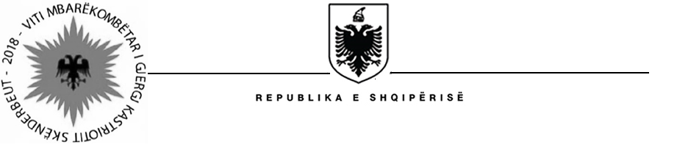

MINISTRY OF HEALTH AND SOCIAL PROTECTION
SOCIAL ASSISTANCE MODERNIZATION PROJECT (SAMP)

Contract Award
Project Name: Social Assistance Modernization Project
Country: Albania
IBRD Loan Number: 8141-AL
Report Period: November 27, 2018
Procurement Reference: | Ref. no. SAMP/CS/CQ/01-2018
Description of the assignment: | “Update and delivery of training module of disability evaluation staff, family and specialist doctors and social administrators on implementation of disability evaluation reform in all administrative units of Tirana Municipality”
Consultant’s Name: | “MIKE” Center
Consultant’s Address : | Rr. Budi 56/2, Tirana, Albania, Tirana, Albania
Date of Contract Signature: | November 14, 2018
Contract amount: | 60,496 EUR (sixty thousands four hundred and ninety six EUR) – VAT included
Period of the assignment : | From November 15, 2018 and continuing through December 31, 2018

