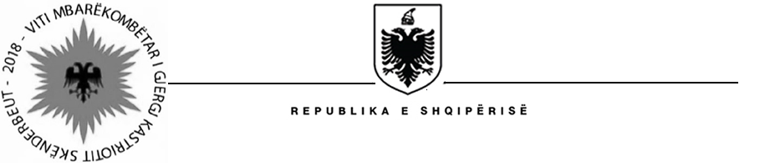

MINISTRY OF HEALTH AND SOCIAL PROTECTION
SOCIAL ASSISTANCE MODERNIZATION PROJECT (SAMP)

Contract Award

Project Name: Social Assistance Modernization Project
Country: Albania
IBRD Loan Number: 8141-AL

Bid/Contract Reference No: | SAMP/CS/TR (03-06)-2015
Scope of Contract: | Study Tour to Georgia in the framework of NE – purchase of air tickets and accommodation
Duration of Contract: | 12-16 November 2018
Evaluation Currency: | ALL
Awarded Bidder(s)
Name: | AR & LO Travel-Blu tour operator
Address: | Rr. “Abdyl Frasheri”, Pallati i ri "De Rada" nr. 3/3, Tirane, Albania
Contract Price: | 1,963,998 (one million and nine hundred sixty three thousand and nine hundred and ninety eight) LEK

