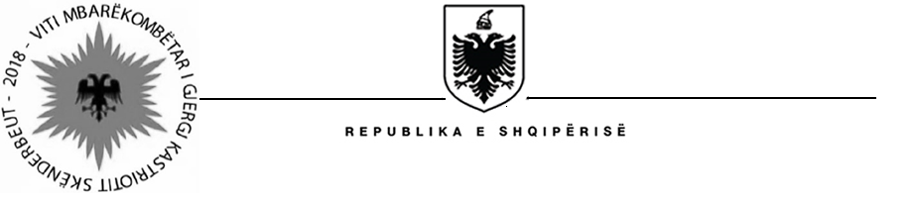

MINISTRY OF HEALTH AND SOCIAL PROTECTION
SOCIAL ASSISTANCE MODERNIZATION PROJECT (SAMP)

Contract Award
Project Name: Social Assistance Modernization Project
Country: Albania
IBRD Loan Number: 8141-AL
Report Period: October 30, 2018
Procurement Reference: | Ref. no. SAMP/CS/CQ/07-2016
Description of the assignment: | “Design of methodologies and delivery of training for building, maintaining and updating a risk profile (including cross-checking procedures) for NE”
Consultant’s Name: | Positive Development Partnership (PDP)
Consultant’s Address : | Rr. “Ana Komnena”, Bulevardi i Dafinave, P. 16, Apt. 40, Tirana, Albania
Date of Contract Signature: | October 22, 2018
Contract amount: | 79, 500 EUR (seventy nine thousands five hundred EUR) – VAT included
Period of the assignment : | From October 22, 2018 and continuing through December 28, 2018

