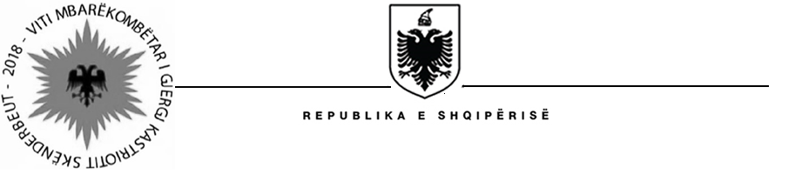

MINISTRIA E SHËNDETËSISË DHE MBROJTJES SOCIALE
Social Assistance Modernization Project (SAMP)

Tirana on June 18, 2018

Contract Award

Procurement Reference: | Ref. no. SAMP/CS/CQ/04-2016
Description of the assignment : | “Improve legal framework for prevention and detection of fraud, error and corruption in NE. Design of improved error, fraud, and framework and implementation procedures for NE. Training of social inspectors on improved inspection, sanction and remedy/recovery policy”
Consultant’s Name : | In the Family for the Family
Consultant’s Address : | Rr. Komuna e Parisit, Pallatet Alban, Hyrja nr. 1, Ap. Nr. 18, Tirana, Albania,  Tel. ++ 355. 067 44 63 338,  E-mail: nfpf_org@yahoo.com
Date of Contract Signature: | June 13, 2018
Contract amount: | 74,831 EUR (VAT 20% included) (seventy- four thousands eight hundred and thirty one EUR)
Period of the assignment : | From June 13, 2018 until to September 26, 2018

