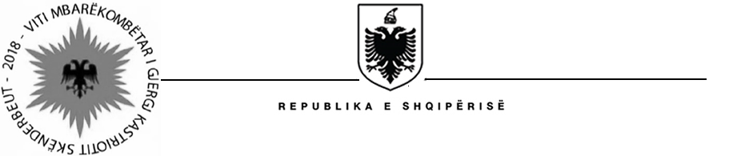
MINISTRIA E SHËNDETËSISË DHE MBROJTJES SOCIALE
Social Assistance Modernization Project (SAMP)

Tirana on, May 18, 2018

Short List Establish

Procurement Reference: | Ref: SAMP/CS/QCBS/14-2016
Description of the assignment : | “Design of Communications Strategy, including the Campaign Action Plan, and Implementation of Communications Campaign Activities for Disability Assistance reform”
Shortlist established : | The following shortlisted consultants are selected to be invited for submission of the technical and financial proposal for assignment: “Design of Communications Strategy, including the Campaign Action Plan, and Implementation of Communications Campaign Activities for Disability Assistance reform”

No. | Name of Consultant | Country | Type of associations between firms |  | Leader Partner
1. | PIK CREATIVE SH.P.K | Albania |  | Consulting Firm | PIK CREATIVE SH.P.K
2. | Iceberg Communication | Albania |  | Consulting Firm | Iceberg Communication
3. | JAVA Publicity | Albania |  | Consulting Firm | JAVA Publicity
4. | Vektor Advertising | Albania |  | Consulting Firm | Vektor Advertising
5. | Albanian Center for Economic Research (ACER) | Albania |  | Consulting Firm | Albanian Center for Economic Research (ACER)
6. | LDK Consultants Global EEIB & Congress Service Center | Belgium & FYROM |  | Sub consultancy | LDK Consultants Global EEIB

The standby* list is as below:

No. | Name of Consultant | Country | Type of associations between firms | Leader Partner
1. | Management Development Associates (MDA) | Kosovo | Consulting Firm | Management Development Associates (MDA)
2. | Optima Communication | Albania | Consulting Firm | Optima Communication

Note*: These companies will substitute any shortlisted firms that may choose not to participate in the selection process

