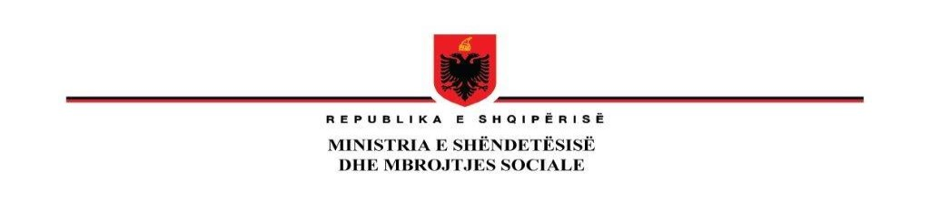

**ADDENDUM NO 1**

**Issued on 26th September 2023**

*to the bidding documents for the tender CIVIL WORKS FOR THE REHABILITATION OF PSYCHIATRIC HOSPITAL IN UNIVERSITY HOSPITAL CENTER "MOTHER TERESA* *AL-MH-332201-CW-RFB*

|  |  |  |
| --- | --- | --- |
| **ITB** | **Original Clause** | **Amended/ corrected Clause** |
| **ITB 22.1** | For **Bid submission purposes** only, the Employer’s address is:  **Ministry of Health and Social Protection**  Manager Address: Ministry of Health and Social protection, **Rr. Kavajes- Tirana Albania**  City: **Tirana**  ZIP Code: **1000**  Country: **Albania**  The deadline for Bid submission is:  **Date 27 September 2023**  Time: 11:00 AM  Bidders ***shall not*** have the option of submitting their Bids electronically. | For **Bid submission purposes** only, the Employer’s address is:  **Ministry of Health and Social Protection**  Manager Address: Ministry of Health and Social protection, **Rr. Kavajes- Tirana Albania**  City: **Tirana**  ZIP Code: **1000**  Country: **Albania**  The deadline for Bid submission is:  **Date 06 October 2023**  Time: 10:00 AM  Bidders ***shall not*** have the option of submitting their Bids electronically. |
| **ITB 25.1** | **Ministry of Health and Social Protection**  Manager Address: Ministry of Health and Social protection, **Rr. Kavajes- Tirana Albania**  City: **Tirana**  ZIP Code: **1000**  Country: **Albania**  The Public Bid Opening shall take place on:  **Date : 27 September 2023**  Time: 11:15 AM | **Ministry of Health and Social Protection**  Manager Address: Ministry of Health and Social protection, **Rr. Kavajes- Tirana Albania**  City: **Tirana**  ZIP Code: **1000**  Country: **Albania**  The Public Bid Opening shall take place on:  **Date : 06 October 2023**  Time: 10:15 AM |
| **ITB 18.1** | The Bid shall be valid until: 25 January 2024 | The Bid shall be valid until: 03 February 2024 |
| **ITB 19.1** | A Bid Security shall be required. The Bid Security shall be in the form of Bank Guarantee.  The amount and currency of the Bid security shall be 3,870,000 ALL  The Bid security shall be valid for twenty-eight days beyond original date of expiry of Bid validity, or beyond any extended date if requested under ITB 18.2. The Bid security shall be valid at least until 22 February 2024. | A Bid Security shall be required. The Bid Security shall be in the form of Bank Guarantee.  The amount and currency of the Bid security shall be 3,870,000 ALL  The Bid security shall be valid for twenty-eight days beyond original date of expiry of Bid validity, or beyond any extended date if requested under ITB 18.2. The Bid security shall be valid at least until 02 March 2024. |

**All other requirements in the BDs remain unchanged.**