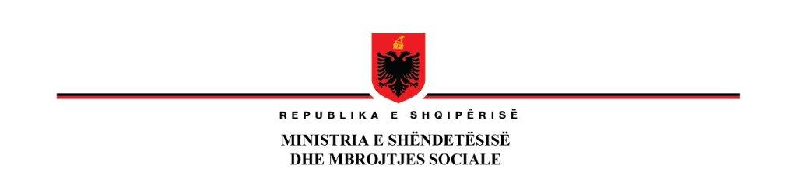

**25 October 2023**

**Notification of Award**

|  |  |
| --- | --- |
| **Country:** | Albania |
| **Project Name:** | Additional Financing of health System Improvement Project |
| **Loan Number:** | Loan No. 93060  Identification No. P144688 |
| **Contract name:** | Medical Equipment for Hospitals AL-MH-363454-GO-RFB  LOT 4 : PHACO EQUIPMENT |
| **Name of the**  **winner** | Awarded to **PEGASUS sh.p.k**  *Rr. “Siri Kodra”, nr.149, 1001, Tirana, Albania* |
| **Price** | **Total Price: CIP final destination**  Accepted Contract Amount of 128,000 Euro (one hundred and twenty-eight thousand (VAT Exclusive) and 25,600 Euro (VAT).  Total 153,600 Euro VAT inclusive |

**DEPUTYMINISTER**

**Entela RAMOSAÇAJ**