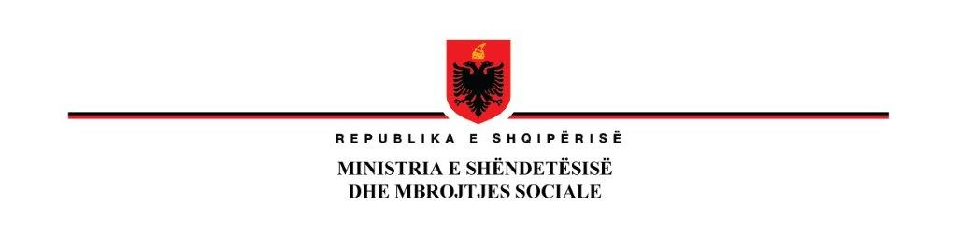

**25 October 2023**

**Notification of Award**

|  |  |
| --- | --- |
| **Country:** | Albania |
| **Project Name:** | Additional Financing of health System Improvement Project |
| **Loan Number:** | Loan No. 93060  Identification No. P144688 |
| **Contract name:** | Medical Equipment for Hospitals AL-MH-363454-GO-RFB  Lot 1 Apheresis |
| **Name of the**  **winner** | Awarded to **EUROMED shpk**  *Blv. Bajram Curri, Pallati 298/H16**1004, Tirana, Albania* |
| **Price** | **Total Price: CIP final destination**  Accepted Contract Amount of 98,000 Euro (VAT Exclusive) and 19,600 Euro VAT  **Total 117,600 Euro VAT inclusive** |

**DEPUTYMINISTER**

**Entela RAMOSAÇAJ**